

Lecturer: Mr Su Lee Seng

|  |  |  |
| --- | --- | --- |
| Member’s Name | ID | Course |
| Goh Yi Cheng (Group Leader) | 2206335 | AM |
| Toh Yong Cheng | 2206765 | AM |
| Anson Yong Wei Sheng | 2202789 | AM |

Cover Page………………………………………………………………………..1

Tablet Of Content…………………………………………………………………2

Objective………………………………………………………………………….3

1. Introduction…………………………………………………………………...3-4
2. Data Exploration
   1. Raw Statistic Preview…………………………………………….......5-7
   2. Distribution Analysis – Categorical Features………………………...8-9
   3. Distribution Analysis – Numerical Features…………………………..9-10

3.0 Data Splitting………………………………………………………………….11-12

4.0 Data Preprocessing

4.1 Remove Duplicates……………………………………………………13

4.2 Handling Missing Target Values………………………………………13

4.3 Handling Faulty Data……………………………………………….....14-15

4.4 Imputation of Missing Values………………………………………...16-19

4.5 Data Analysis before Scaling

4.5.1 Univariate Analysis…………………………………………..20

4.5.2 Bivariate Analysis

4.5.2A Pair plot……………………………………………..21

4.5.2B Heatmap……………………………………………...22

4.5.2C Cramer’s V Correlation Matrix……………………..23

4.5.2D Point biserial Correlation Matrix………………...…24

4.5.2E Chi-Square Statistic Heatmap……………………....25

4.5.2F Violin Plot………………………………………...…26

4.5.3 Multivariate Analysis

4.5.3A Stacked Bar Chart……………………………………27

4.5.3B Pairplot……………………………………………….28

4.5.3D 3D-Scatter Plot……………………………………….29

4.5.4 Visualization of Skewness

4.5.1A QQ Plots and Density Plots…………………………..30-31

4.6 Transformation

4.6.1 Yeo-Johnson Transformation for highly skewed features…….31-32

4.6.2 Standardization for numerical features………………………..32-33

4.6.3 Label Encoding for categorical features..34

4.7 Save Preprocessed train, test and validate set into CSV…………………35

5.0 Model Creation

5.1 Model Training…………………………………………………36

5.1.1 K-Nearest Neighbours…………………………………………..37-39

5.1.2 SVM (Support Vector Machine)………………………………...40-41

5.1.3 Logistic Regression………………………………………………42-44

5.1.4 Naïve Bayes……………………………………………………..45-47

5.1.5 Neural Network…………………………………………………..48-50

5.1.6 Decision Tree……………………………………………………..51

5.1.7 Random Forest…………………………………………………….52-54

5.1.8 XG Boost…………………………………………………………..55-59

5.1.9 ADA Boost…………………………………………………………60-63

5.1.10 Gradient Boosting………………………………………………….64-67

5.2 Model Evaluation and Comparison

5.2.1 Comparison using Confusion matrix……………………………68-70

5.2.2 Classification report (Weighted) & ROC-AUC…………………71-72

5.2.3 ROC curves……………………………………………………….73-74

5.3 Model Selection…………………….…………………………….……….75

6.0 Model Selection

6.1 Data Preprocessing on new Datasets…………………………………..75-77

6.2 Data Prediction………………………………………………………….78

7.0 Remarks and Reflection…………………………………………………………..79

**Objective**

The objective of this analysis is to select a suitable machine learning model and utilize a cleaned and preprocessed dataset to train the model for heart disease prediction. Various model will be tested such that the model that is most accurate can be selected. The selected trained model will then be used to determine whether each of the 10 new patients is at risk of heart disease.

**1.0 Introduction**

The following table introduces each of the variable that is used in the dataset to train the model. Outlier or any other form of error value has yet to be cleaned.

**Table 1 Description of Feature/Variable**

|  |  |  |  |
| --- | --- | --- | --- |
| **Variable name** | **Type of variable** | **Description** | **Logical range of value** |
| *age* | Discrete | The age of the patient | 29 - 79 |
| *sex* | Discrete | The gender of the patient  0 : Female  1 : Male | 0 and 1 |
| *cp* | Discrete | Chest Pain Type  0 : Typical angina (Strong indicator of heart disease)  1 : Atypical angina  2 : Non-anginal pain  3 : Asymptomatic | 0, 1, 2, 3 |
| *trestbps* | Continuous | Resting blood pressure of patient (mm/hg) | 94 - 200 |
| *chol* | Continuous | Serum Cholesterol (mm/hg) | 126 to 564 |
| *fbs* | Discrete | Fasting blood sugar level  0 : level does not exceed 120mg/dl  1 : level exceed 120mg/dl | 0 and 1 |
| *restecg* | Discrete | Resting electrocardiographic results  0 : Normal  1 : Having ST-T wave abnormality  2 : Shows probable or definite left ventricular hypertrophy | 0, 1, 2 |
| *thalach* | Continuous | Maximum heart rate achieved during stress test | 71 - 220 |
| *exang* | Discrete | Exercise-induced angina  0 : No  1 : Yes | 0 and 1 |
| *oldpeak* | Continuous | ST depression induced by exercise relative to rest (>2mm shows stronger sign of heart disease) | 0 – 6.2 |
| *slope* | Discrete | Slope of peak exercise ST segment  0 : Upsloping  1 : Flat  2 : Downsloping (High risk of heart disease) | 0, 1, 2 |
| *ca* | Discrete | Number of major vessels colored by fluoroscopy | 0, 1, 2, 3 |
| *thal* | Discrete | Thalium stress test result:  0 : Not described (error)  1 : Normal  2 : Fixed defect  3 : Reversible defect | 1, 2, 3 |
| *target* | Discrete | Heart disease status  0 : no disease  1 : presence of disease | 0 and 1 |

**2.0 Data Exploration**

2.1 Raw Statistic Preview

We first start with the data exploration that provide simple understanding of the complete raw data set including showing the variable of the dataset, amount of row and column, list of features, summary statistics along with the distribution of features. Any modifications on the dataset would be avoided in this step.

**The reason we perform data exploration before splitting instead of performing on training set after splitting is because of:

**A) Understanding the Overall Data Distribution:**

We can view a complete picture of the data’s characteristics that helps us understand the general trends and identify any potential issues (like class imbalance or skewed features) that could influence the splitting strategy or preprocessing steps.

**B) Informing Preprocessing Decisions:**

After knowing the distribution of the full dataset, we can make more informed decisions on how to handle missing values, outliers. If we split the data first and then explore only the training set, we may face the risk of not seeing how the test set could behave or be distributed and not get a clear view of overall patterns.

# Preview of data frame

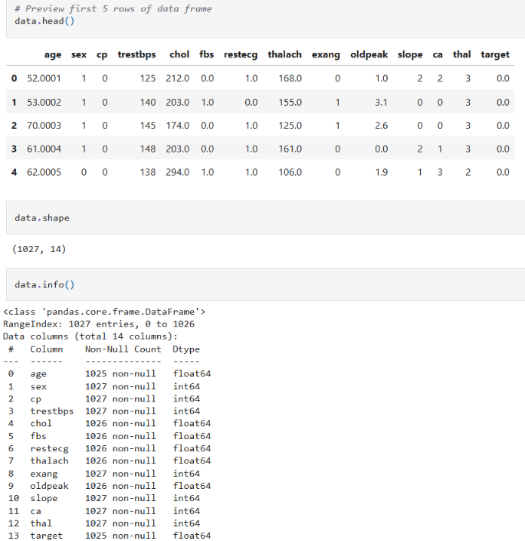

# dataset consists of **1,027 rows** and **14 columns**



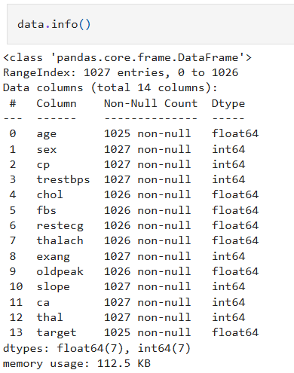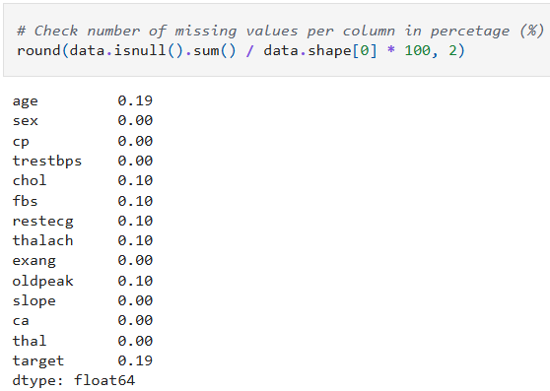

- We can see that some of the data type require conversion and there **exists** some **null values** within the datasets  
- The percentage of missing value for each column is displayed to get a rough estimate on amount of missing data.

# Summary of data frame and unique values of categorical features

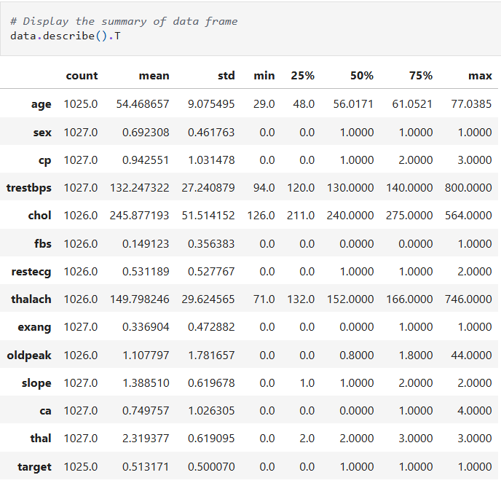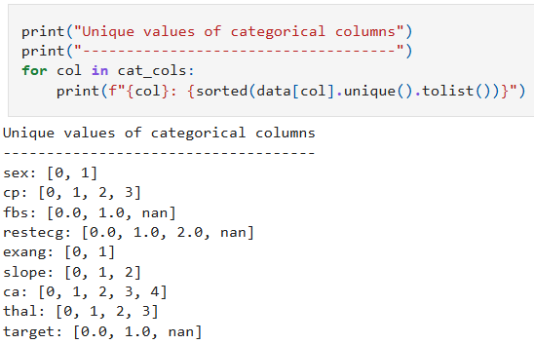

**Faulty data**

v

- From the figure above, we can see that there **exists some ‘faulty data’**. Faulty data is **not** an **outlier**, but it is something that are impossible or logically incorrect. In the part of preprocessing, we will be handling these issues.

- For understanding of the structure of categorical features, the **unique value from** each **categorical column** is **extracted**. The purpose of this step is to identify any inconsistencies such as spelling mistake.

- Any unexpected values that may indicate data entry errors are shown to ensure all categories are valid for encoding in later processing steps. An example can be seen in the **value of 4 in ca** where it is **categorized as faulty data**.

# Categorical features and numerical features

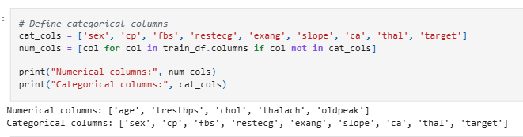

- features are separated into a list for numerical data and categorical data such that it is easier for other coding purposes, graph plotting and so on.

# Existence of duplicates values

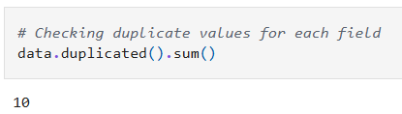

**2.2 Distribution Analysis – Categorical features**

This analysis focuses on visualizing the distributions of numerical features in the raw dataset before applying any preprocessing. The purpose of this step is to identify the distribution patterns of the data, detect potential outlier or faulty data that require handling, understand feature scaling that needs to be done before transformation is applied, and to ensure that feature distributions make sense based on domain knowledge. Since preprocessing such as normalization, standardization can alter distributions, we perform this analysis only on the training set to maintain consistency and avoid data leakage.

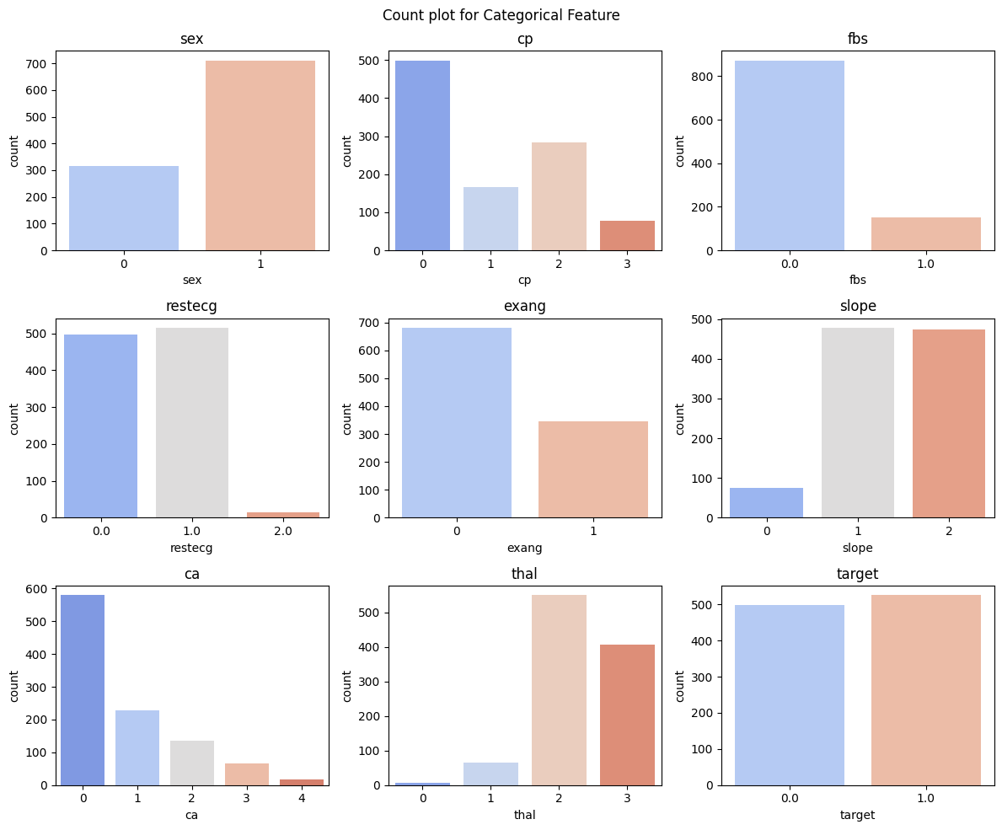

From the count plot above for raw data set, the following observation can be made:

* The number of males exceeds the number of females. (Chart 1)
* Most individuals in the dataset experience asymptomatic chest pain (category 0), which is a common indicator of heart disease. (Chart 2)
* Most individuals have low fasting blood sugar levels. (Chart 3)
* Most individuals have normal Resting Electrocardiographic (ECG) results or ST-T wave abnormalities. Only a small number (fewer than 25) exhibit probable or definite left ventricular hypertrophy, which is associated with high blood pressure and heart failure. (Chart 4)
* The number of people who experience chest pain during exercise is about half of those who do not. (Chart 5)
* For most individuals, the slope of peak exercise (ST segment) remains flat (indicating a lack of oxygen) or decreases (which suggests a high risk of heart disease). (Chart 6)
* A significant number of individuals exhibit some level of serious blockage in their blood vessels. (Chart 7)
* Most individuals show a reversible defect in the Thallium Stress Test, which is strongly associated with heart disease. (Chart 8)
* The number of heart disease patients in this testing set is nearly equal to the number of healthy individuals, indicating a balanced dataset. (Chart 9)

**2.3 Distribution Analysis – Numerical features**

The graph below shows the distribution of the numerical features through histogram and boxplot. The reason we picked histogram and boxplot is since histogram can show the distribution of a data clearly while boxplot can show any potential outlier or illogical value.

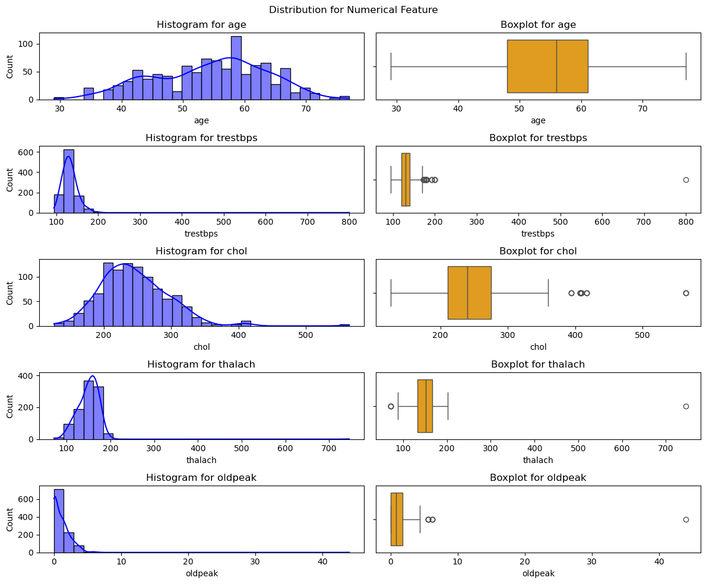

From the figure above, we can obtain some insights:

1. Age follows a normal distribution, most individuals age between 40-70 years old, and no significant outlier is present for age. (Chart 2)
2. Most value of the Resting Blood Pressure, *trestbps* falls between 100 to 200 mmHg. An extreme value above 700 is present which indicates a possible error. (Chart 2)
3. The distribution for cholesterol is rightly- skewed. One individual with cholesterol level that exceeds 500mg/dl may indicate a possible error. (Chart 3)
4. The value of maximum heart rate, *thalach* falls between 100- 200 bpm. Outliers are present at the lower end which may suggest potential individuals with abnormally low heart rate. The outlier value of 700 at the upper end indicates a possible error. (Chart 4)
5. The distribution of ST depression, *oldpeak* is highly right skewed which indicate most individuals have a low ST depression of nearing zero. Several extreme values are present which indicates a few individuals with very high ST depressions levels. The unrealistic outlier exceeds 40 mm indicates a possible error. (Chart 5)

**3.0 Data Splitting**

In our project, we first split the data before preprocessing to prevent data leakage. This ensures that data transformations (like scaling or encoding) do not influence the validation or testing sets, which could lead to misleading results.

We divide the dataset into three parts:

1) Training Set (70%) – The model learns patterns and relationships from this data. It is the largest portion because a well-trained model needs enough data to generalize well.

2) Validation Set (15%) – This helps fine-tune the model by testing it on unseen data during training. It ensures the model does not overfit (perform well only on training data but poorly on new data).

3) Testing Set (15%) – Once the model is finalized, the test set evaluates its performance on completely new data, simulating real-world scenarios.

By performing data splitting before preprocessing, we avoid data leakage, which could make the model appear more accurate than it is. This step helps maintain the integrity of our results and ensures fair evaluation.

# Output of amount of data for the 3 set after splitting

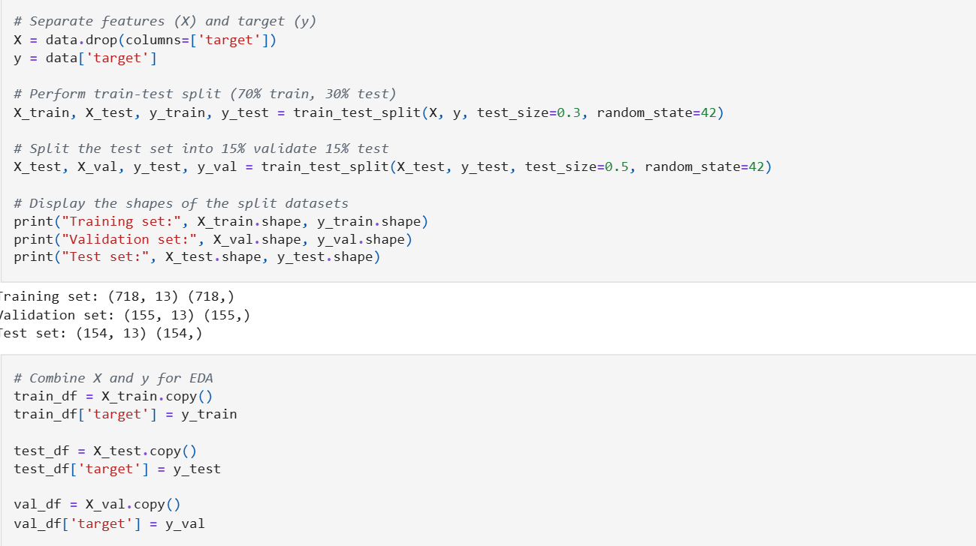

# Combining X(feature) and y(target) of training, testing and validation set into a single data frame respectively



After data splitting, the number of duplicated rows and null value for each of the variable for each set is displayed. The purpose of this process is to know what we should worked on.

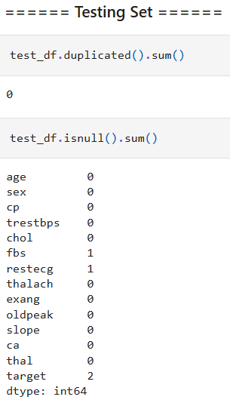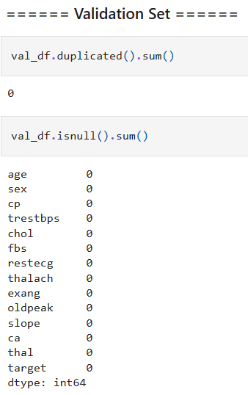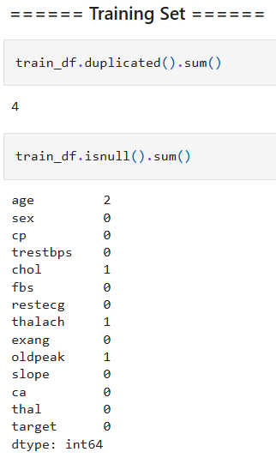

**4.0 Data Preprocessing**

**4.1 Remove Duplicates**

In the previous stage, we **only** found out that **training set contains duplicated value**. Hence, in this stage, duplicated value will be removed since it can give misleading insight by distorting the analysis through overfitting.

# Removing duplicated values

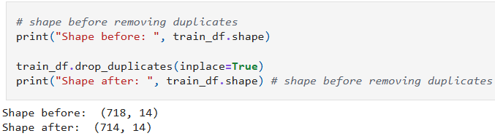

**4.2 Handling Missing Target Values**

Since the target variable is what our model is trying to predict, any row where the target value is NaN (missing) is removed. Keeping such rows would not be useful because they provide no learning signal for the model.

# Only testing set having missing target values

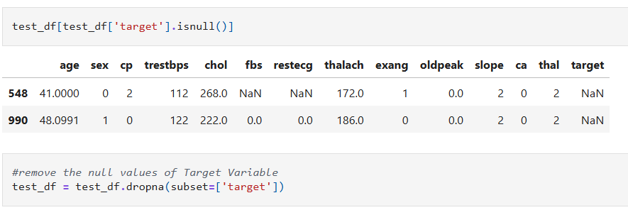

By removing these rows, we ensure that the dataset only contains meaningful examples, leading to better training and evaluation results.

**4.3 Handling Faulty Data**

During the distribution analysis and data summary, we identified faulty data—values that are impossible or logically incorrect. These values must be handled properly to ensure model accuracy and consistency. Faulty data are first replaced with null value so that imputation can be performed later to obtain a more logical value. The following is a list of what is going to be replaced by a null value:

1. Any value of ca that is not 0,1,2 or 3
2. Any value of thalach that are less than 0 or greater than 220
3. Any value of oldpeak that are less than 0 or greater than 6.2
4. Any value of trestbps that are less than 94 or greater than 200
5. Any thal value that are not 1,2 or 3
6. Error Data

The Table below is a list of any variable that has an illogical value and the reason behind it

|  |  |  |
| --- | --- | --- |
| **No** | **Error Variable** | **Reason** |
| 1 | trestbps | A resting blood pressure of 800 is impossible for a human body to be sustained |
| 2 | thalach | It is exceedingly rare for a human heart rate to achieve more than 220 bps |
| 3 | oldpeak | It is exceedingly rare for oldpeak value to reach more than 6.2 |
| 4 | ca | Human heart only has up to three major coronary arteries |
| 5 | thal | Thal value are only categorize from 1 to 3 |

# Function to replace faulty data with null values

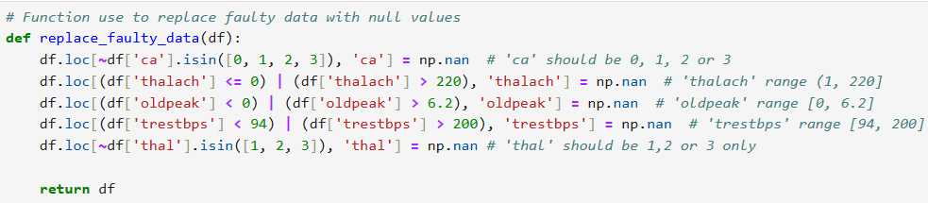

Next, we replace the faulty data for the training, validation and testing set and the amount of null value for the three sets are also displayed to identify the new amount of null value. Imputation will be performed later for training set only.

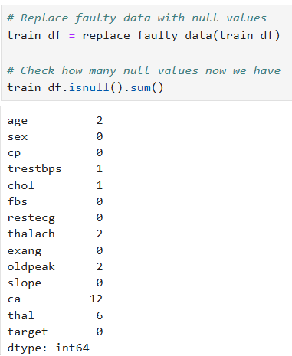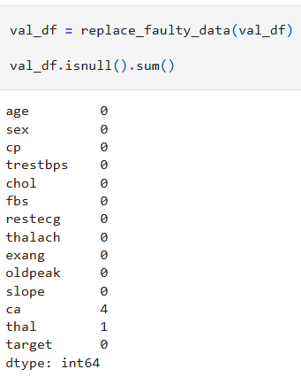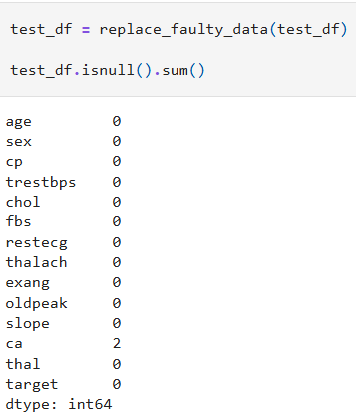

However, after replacing faulty data with NaN for validation set and testing set, we will remove all the NaN values inside them. The key reasons for this decision are:

**A) Ensuring Model Evaluation is Unbiased**

The validation and testing sets are used to measure model performance. If they contain NaN values or imputed, predictions may be unreliable or misleading.

**B) No Data Imputation During Evaluation**

Unlike the training set, where missing values can be imputed (filled in), we do not modify the validation, and testing sets to avoid introducing bias.

**C) Real-World Consistency**

The validation and tests set should represent real-world unseen data, so removing NaN values in these sets prevents biased results caused by imputation method and maintain a clean dataset

# Removing null values of validation and testing set

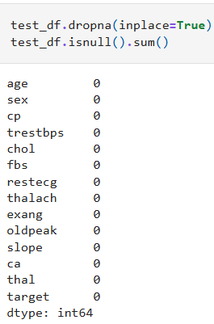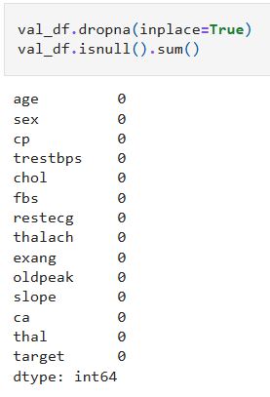

**4.4 Imputation of Missing Values**

In this stage, we will perform imputation on training set. Imputation of null value are done using the random forest model. The reason that we choose random forest for imputation is because of:

**A) Handles Missing Data Effectively**

Random Forest uses proximity-based imputation, meaning it predicts missing values based on similar existing data.

**B) Works Well with Non-Linear Data**

Unlike simple methods (mean/median imputation), Random Forest can capture complex relationships between variables. This leads to better data quality and improves model accuracy.

**C) Preserves Data Distribution**

Instead of filling missing values with a single fixed number, it estimates values based on patterns in the dataset.

# Function to impute numerical features using random forest

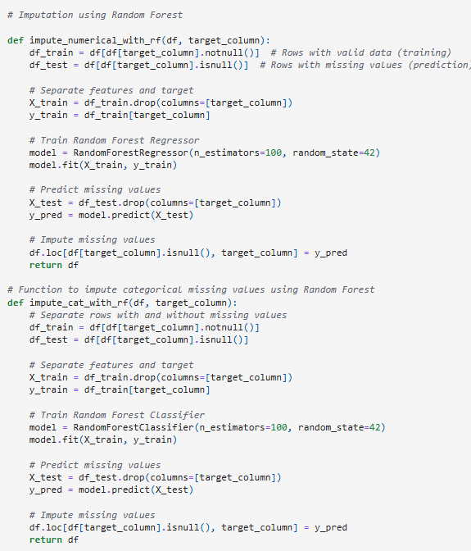

- This function splits data into columns with missing values (to be predicted) and without missing values (for training)

- It trains a Random Forest model on available data and predicts missing values using the trained model.

# Function to impute categorical features using random forest



# Rows of data that contain a null value per rows and more than a null values per rows

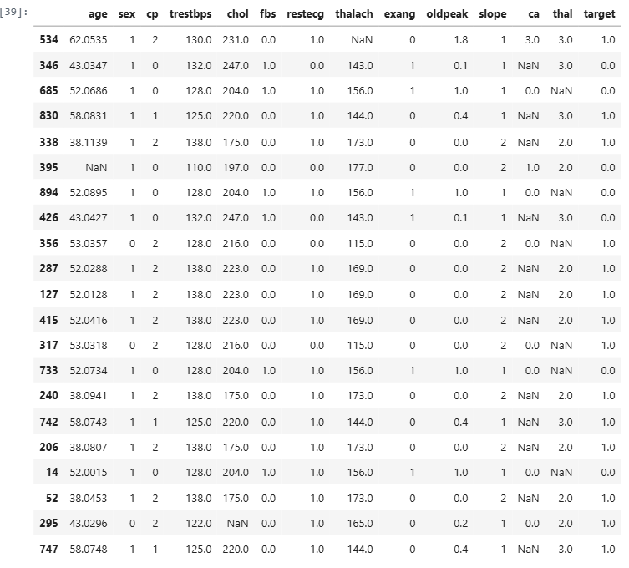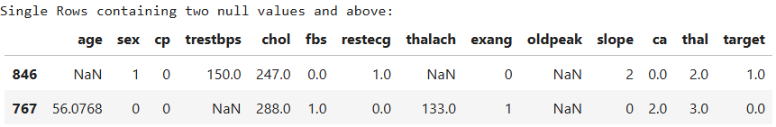

Rows of data that contain null value will be displayed first and it will be displayed again after imputation for checking purposes.

# Function to impute missing values column by column by integrating the two imputation functions mentioned before, one for categorical features and another for numerical features

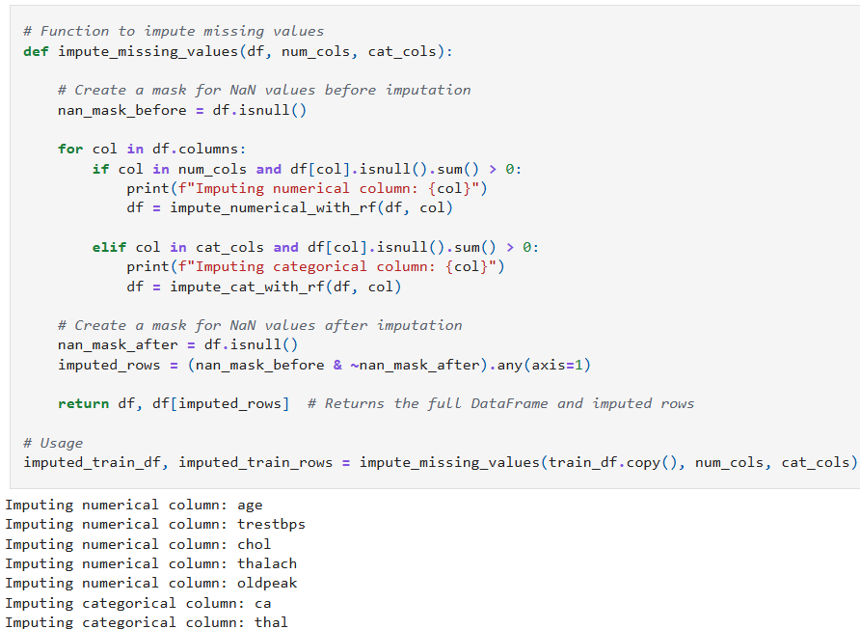

- mask is created to track what missing values that we have imputed

# Rows of data after imputation

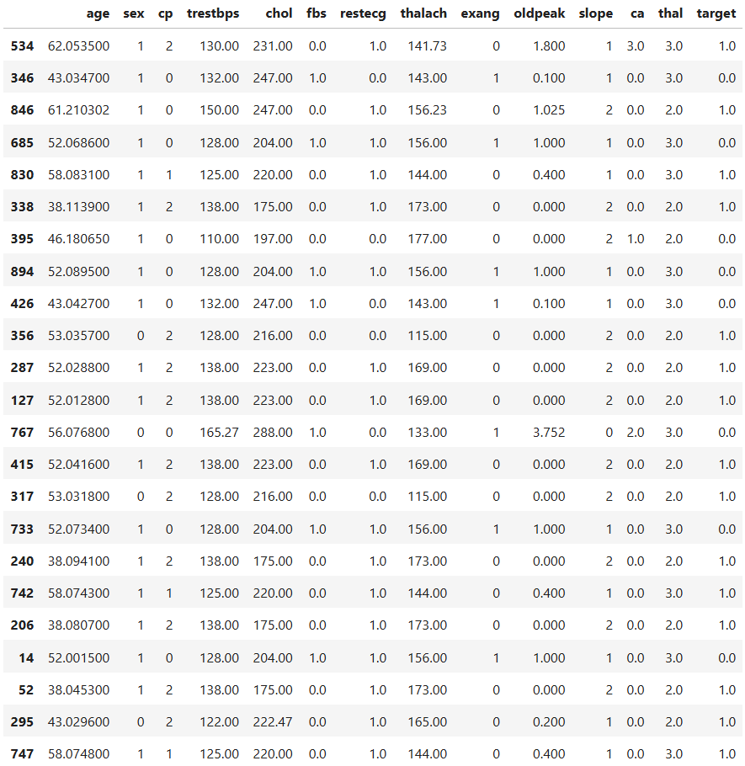

After imputation, data type conversion is performed such that all categorical variable of type float is converted to type integer as it helps in improving the efficiency in modelling by optimizing memory and ensuring the consistency of the format.

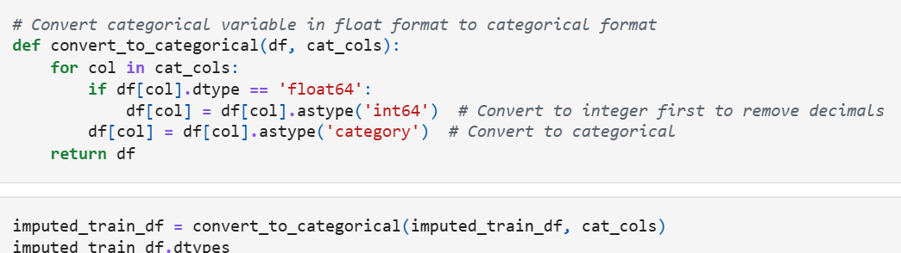

**4.5 Data Analysis before Scaling**

EDA is performed once again after cleaning the data because the new data is considered more meaningful and can provide a more accurate insight. As scaling may cause the loss of original distribution of the data, it is necessary to do EDA on the cleaned data before scaling the new data.

**4.5.1 Univariate Analysis**

After the data is cleaned, EDA is performed once again on training set to show the meaningful data such that any differences in the understanding of the data can be identified

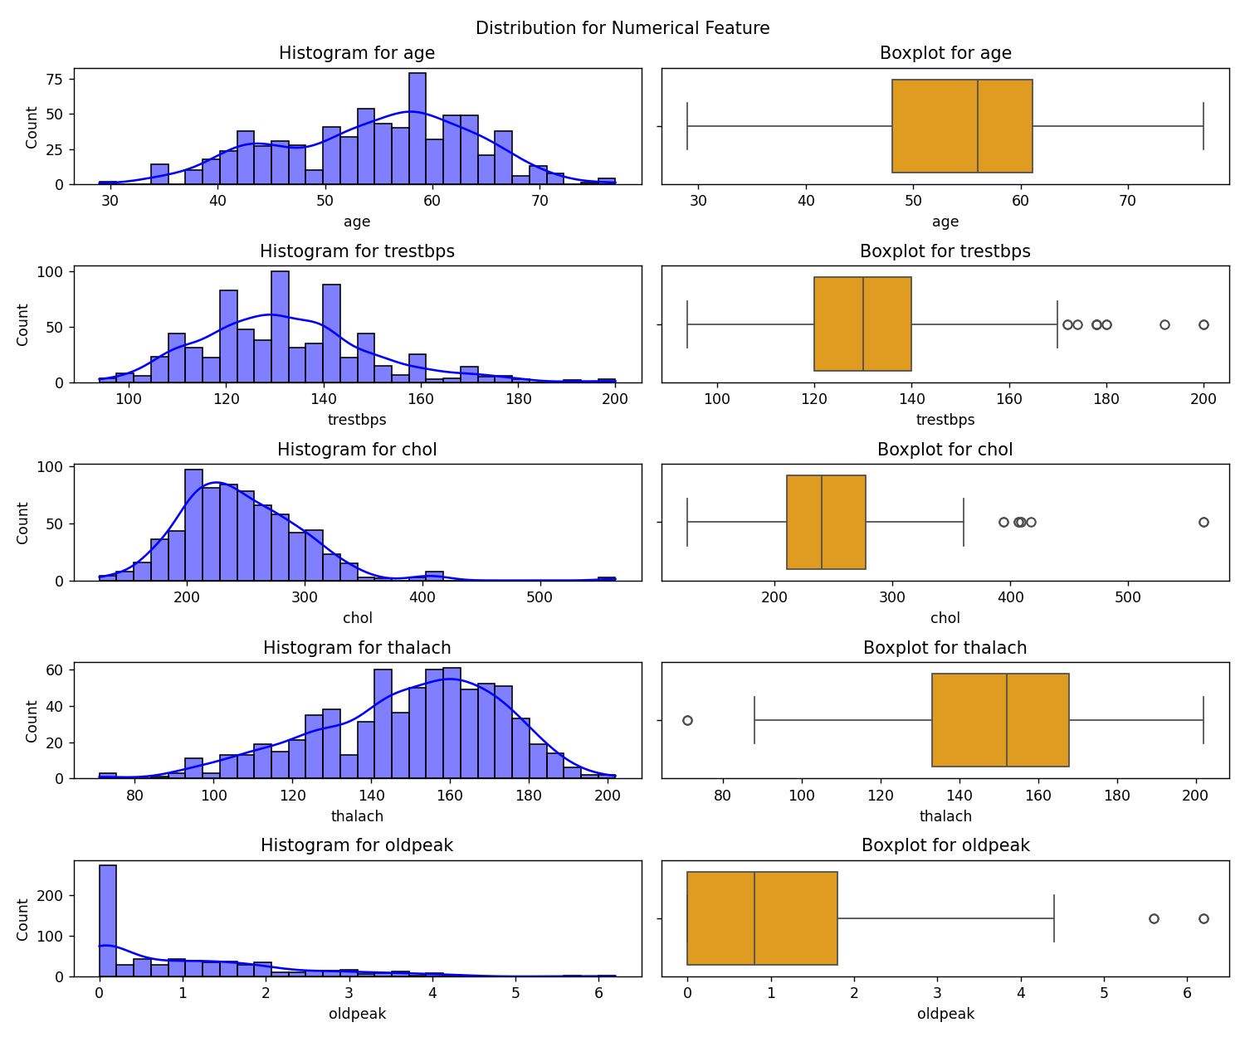

As seen in the graph above, it is much easier to view the summary statistics from the graph when compared to the graph before pre-processing is done. The following are the changes in analysis compared to the analysis previously:

1. It is now clearer that the most patients have a Resting Blood Pressure(trestbps) value of 120 to 150
2. It is now clearer that the value of thalach falls between 140 to 170

3. The faulty data is handled properly making the distribution more reasonable and interpretable

**4.5.2 Bivariate Analysis**

The aim of bivariate analysis is to identify the relationships or correlation between 2 variables. This can either be between numerical and numerical, categorical and categorical, or numerical and categorical. This process is done as we would like to understand whether a variable can affect all the other variables.

**4.5.2A Pair Plot**

In this section, we have used pairplot graph to visualize the relationship through observation and heatmap using calculation to visualize the relationships by using different hue of color.

The following is a pairplot that is used for visualization between numerical variables. Pairplot graph is used as it helps to identify any potential correlation between the variables.

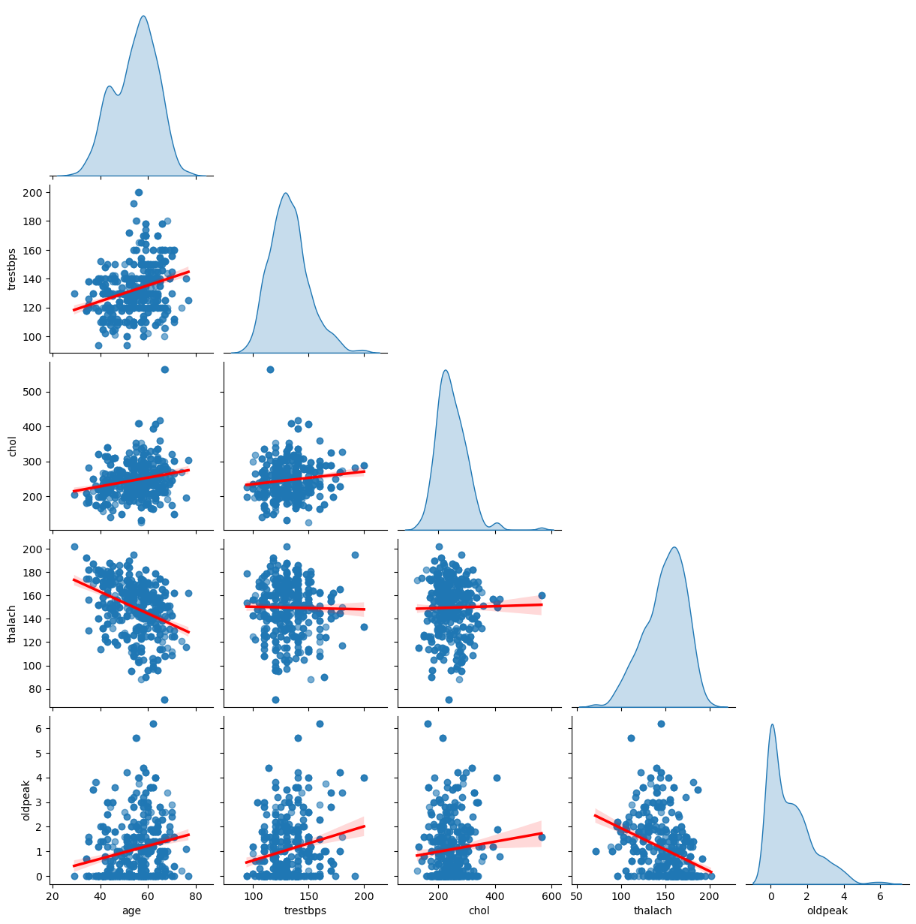

The line on the pairplot graph serves as a reference for the relationship between the numerical values after data cleaning is done. From the pair plot above, we can make the following observation:

1. There is a positive correlation between trestbps and age
2. There is a slight positive correlation between age and cholestrol
3. There is a strong negative correlation between age and thalach
4. There is a slight positive correlation between oldpeak with age and trestbps
5. The is a strong negative correlation between oldpeak and thalach

**4.5.2B Heatmap**

The heatmap below also shows the correlation between the numerical value in value and colors. The deeper the red color, the stronger the positive correlation is. The deeper the blue color, the stronger the negative correlation is.

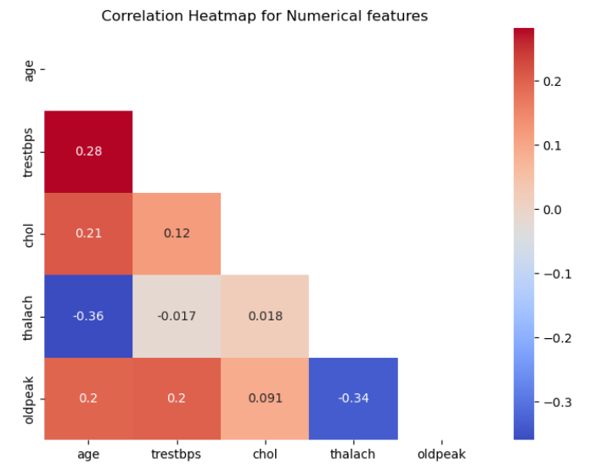

We can make the following observation from the heatmap above:

* There do not exist a strong correlation between numerical features
* There exists a low negative correlation between age and thalach.
* There exists a low positive correlation between age and trestbps.

**4.5.2C Cramer’s V Correlation Matrix**

The heatmap below shows the Cramer’s V statistic with bias correction for two categorical variables. Its serves to identify the strength of association between the categorical variables but does not indicate the linearity between the 2 variables. As this method only measure the strength of association between the 2 categorical variable and not whether they are related positively or negatively, the value only ranges from 0 to 1 where higher value indicates a stronger association.

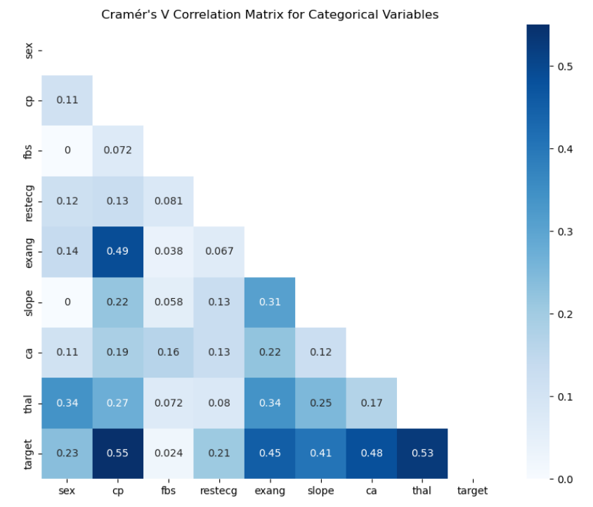

We can make the following observation from the heatmap above:

1. The value of zero indicates that fbs and slope does not have any association with sex.
2. Target has a strong association with cp and thal while it has a moderate association with exang, slope, and ca.
3. Fbs having a value of close to 0 for most of the variable suggest that it does not have any association with most of the categorical variables.

**4.5.2D Point biserial Correlation Matrix**

The heatmap below shows the point biserial correlation between a continuous variable and a dichotomous (binary) variable. The purpose of doing this is for us to understand the strength of correlation between a continuous variable and a dichotomous variable. Dichotomous variable meaning any categorical variable that only have 2 possible values. The value ranges from -1 to 1 as it also measures the positive and negative correlation between the variables.

The heatmap on the right represents the statistical significance (p-values) of the correlations shown in the heatmap on the left, where lower values indicate higher significance.

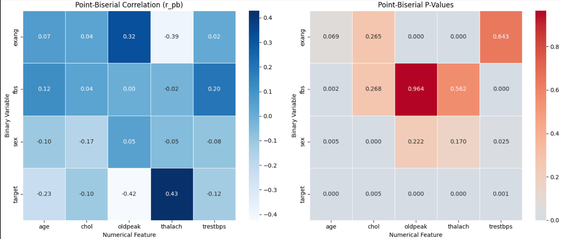

From both heatmap, we have made the following observation:

1. Target and thalach have the strongest positive correlation.
2. Target and oldpeak have the strongest negative correlation.
3. Fbs and oldpeak have no relation at all.
4. Since the left graph indicates that the statistical significance for the observation 1 and 2 have are approximately 0, we can conclude that both the observation is correct.
5. The high p-value for fbs and oldpeak indicates that they do not have a statistically significant relationship which matches with observation 3.

The reasons we are plotting heatmaps for correlation and p-values:  
**i. Correlation alone is not enough**  
- A high correlation does not always mean a useful predictor if it’s not statistically significant.

**ii. Significance alone is not enough  
-** A feature might be statistically significant but still have a weak correlation, making it less valuable.

Together, these two heatmaps help confirm which numerical features are strongly and reliably associated with the target variable.

**4.5.2E Chi-Square Statistic Heatmap**

Chi-Square test is another statistical method that can be used to determine the association between 2 categorical variables by testing their dependency with one another where higher value indicates a stronger relationship. For example, Does smoking status (Yes/No) affect the likelihood of developing lung disease (Yes/No)? Unlike other heatmap, chi-square statistic values are not bounded.

The heatmap on the right shows the p-value of the chi-square test for the left heatmap, where a higher value indicates weaker dependency while lower value indicates stronger dependency.

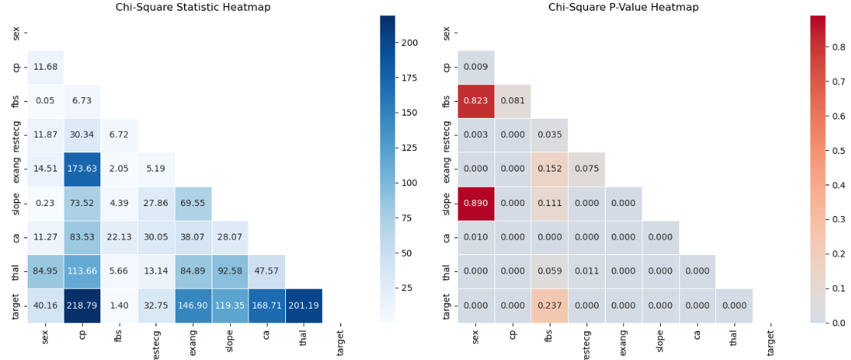

The following observations can be made from the heatmaps above:

1. Target has a strong association with cp and thal
2. Target has the weakest association with fbs
3. Target has a moderate association with exang, slope and ca
4. Since the heatmap the right indicates that the statistical significance for the observation 1 and 3 are approximately 0, we can conclude that both the observation 1 and 3 is correct.
5. The p-value of 0.237 indicates that target and fbs does not have a statistically significant relationship which corroborate with observation 2.

**4.5.2F Violin plot**

The graph below is a violin plot that shows the distribution of age, trestbps and cholesterol with sex. Violin plot is used as it can clearly show the comparison of distribution between 2 numerical variables.

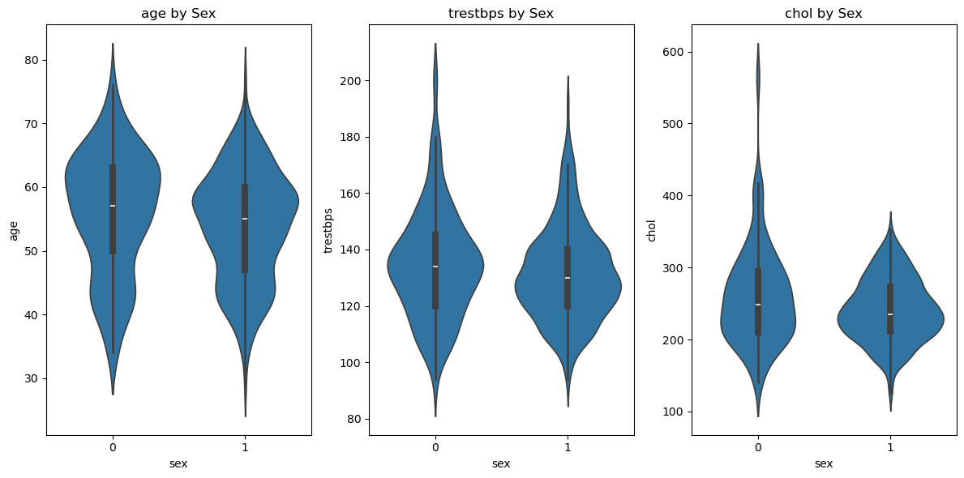

From the graph above, we can make the following observation regarding the dataset:

1. Most female age around 62 years old while most male age about 58 years old.
2. Most female have a trestbps of around 138 while most male have a trestbps of around 130.
3. Most female have a cholesterol level around 200 to 300 while most male have a cholesterol level around 220.

**4.5.3 Multivariate Analysis**

The aim of multivariate analysis is to identify the relationships between 3 or more variable. This step is performed to detect any hidden pattern that cannot be identified by univariate analysis or bivariate analysis.

**4.5.3A Stacked Bar Chart**

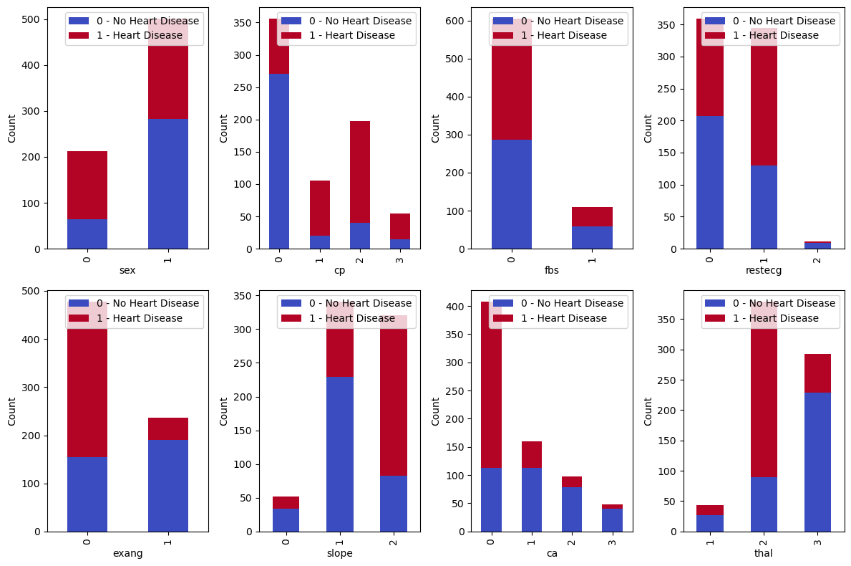

The stacked bar chart compares the count of categorical variable with target. From the chart, the following observation can be made.

1. More than half of the female have heart disease while more than half of the male does not have heart disease
2. Most people with chest pain type 0 (Typical angina) do not have heart disease while most people with other chest pain type have heart disease
3. People with different fbs of different type have almost the same percentage of heart disease
4. More than half of the people with restecg of 0 (Normal) do not have heart disease while more than half of the people with restecg type 1 (Having ST-T wave abnormality) have heart disease
5. Most people with exang value of 0 (No Exercise-induced angina) have heart disease while most people with exang value of 1 do not have heart disease
6. Most people with 0 ca (0 major vessels colored by fluoroscopy) have heart disease
7. More than half of the people with slope type 0 (upsloping) and type 1 (flat) have no heart disease while people with type 2 (downsloping) are more likely to have heart disease
8. Most people with thal of type 0(fixed defect) and type 2 (not described) do not have heart disease while most people with type 1 (reversible defect) have heart disease

**4.5.3B Pairplot (Target as Hue)**

The graph below shows the pairplot of relationship between numerical variables colored by target

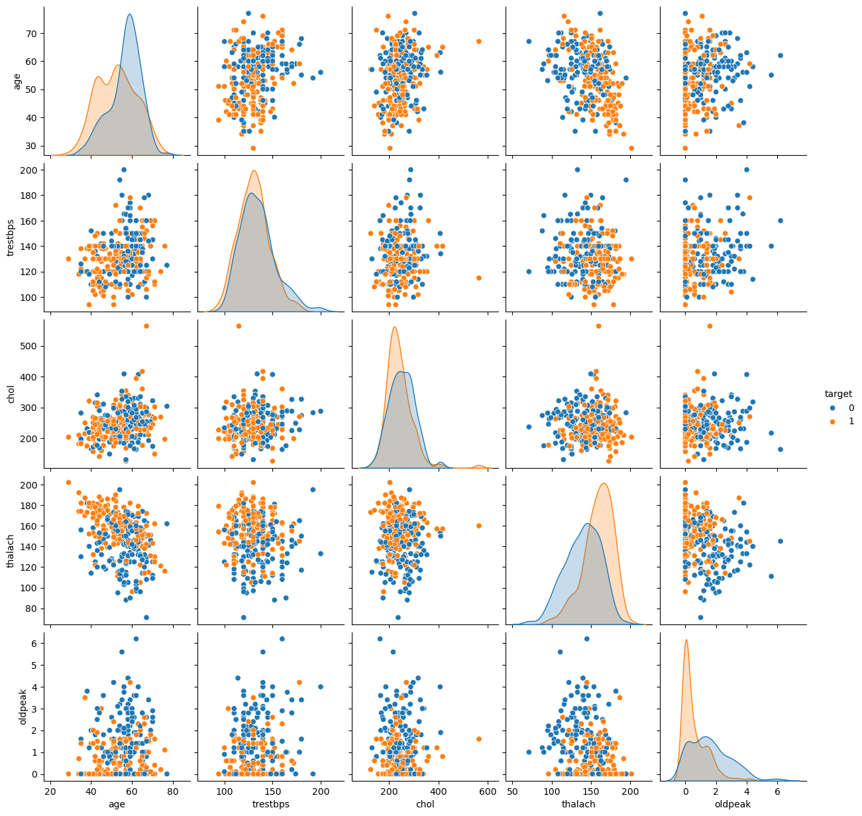

From the graph above we can observe that

1. thalach and oldpeak have the clearest difference between 2 target classes
2. age, trestbps and chol shows partial separation which may indicate them as a weaker standalone predictor

**4.5.3C 3D-Scatter Plot**

The graph below shows the multivariate relation between a few numerical data with target

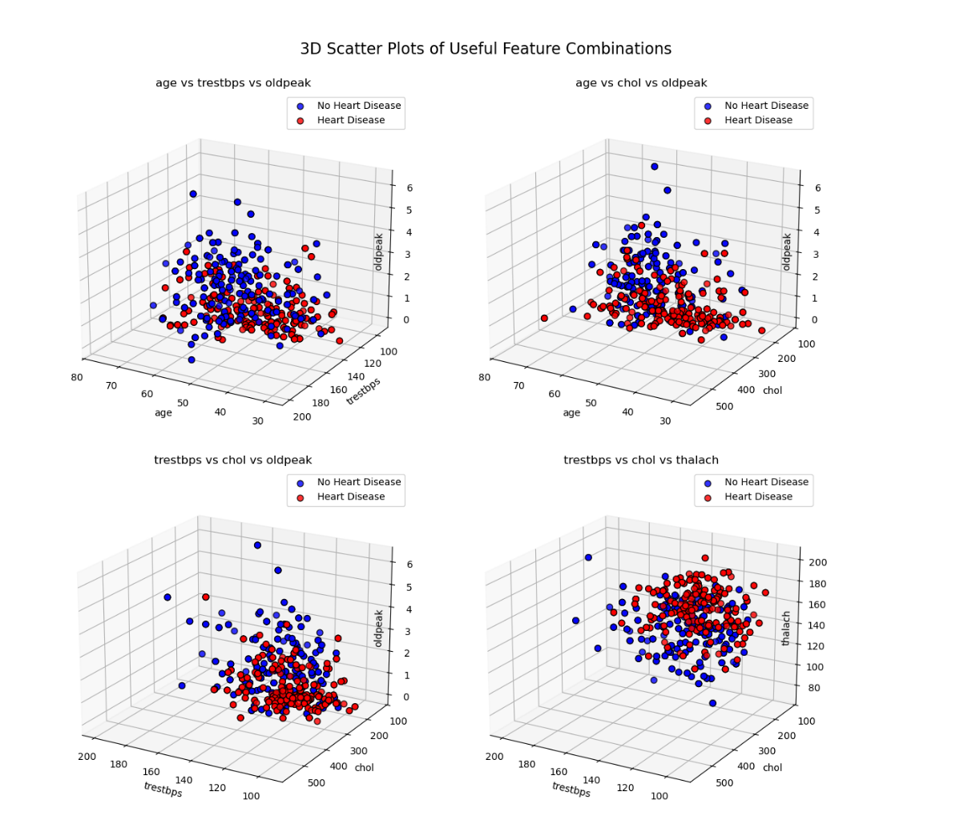

The 3D scatter plots illustrate the relationship between three numerical features. If there is a clear separation between heart disease patients (**red points**) and non-heart disease patients (**blue points**), it indicates that these three numerical features could be useful for predicting the outcome. The four plots above display the most distinct separations among all possible feature combinations.

For example:

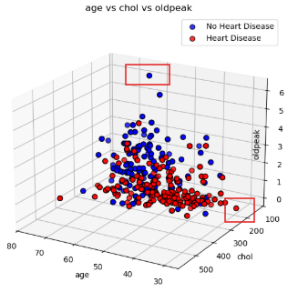

1. From Chart 2, we can observe a clear separation between the patients, where the red and blue points are the farthest apart. The red points represent heart disease patients with high age, high cholesterol, and low oldpeak, whereas the non-patients (blue points) have high cholesterol but high oldpeak and low age.
2. From Chart 4, we can see that heart disease patients and non-patients have **similar cholesterol and trestbps levels**, but heart disease patients have a **higher thalach level** compared to non-patients.

**4.5.4 Visualization of Skewness**

Before applying transformations, visualizing the skewness of numerical features in the training set helps identify variables that may need adjustment. Skewed data can impact model performance, as many algorithms assume a normal distribution. Tools like QQ plots and KDE plots highlight skewness, while numerical skewness values help determine the need for transformation. If skewness is significant, transformations like Yeo-Johnson, log, or square root can help normalize the data, making features more suitable for modeling.

**4.5.4A QQ Plots and Density Plots**

A QQ plot compares the quantiles of our data to the quantiles of a normal distribution. If the data is normally distributed, the points will fall along a straight line. Deviations from this line indicate departures from normality.

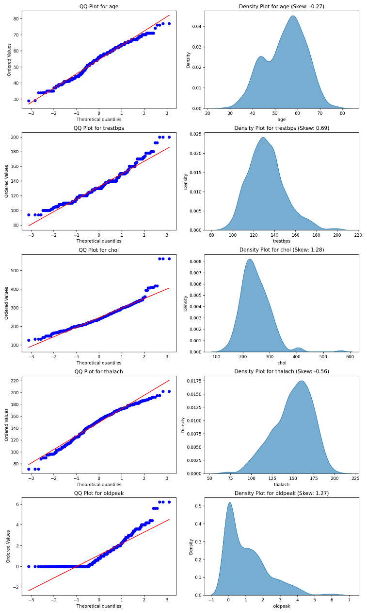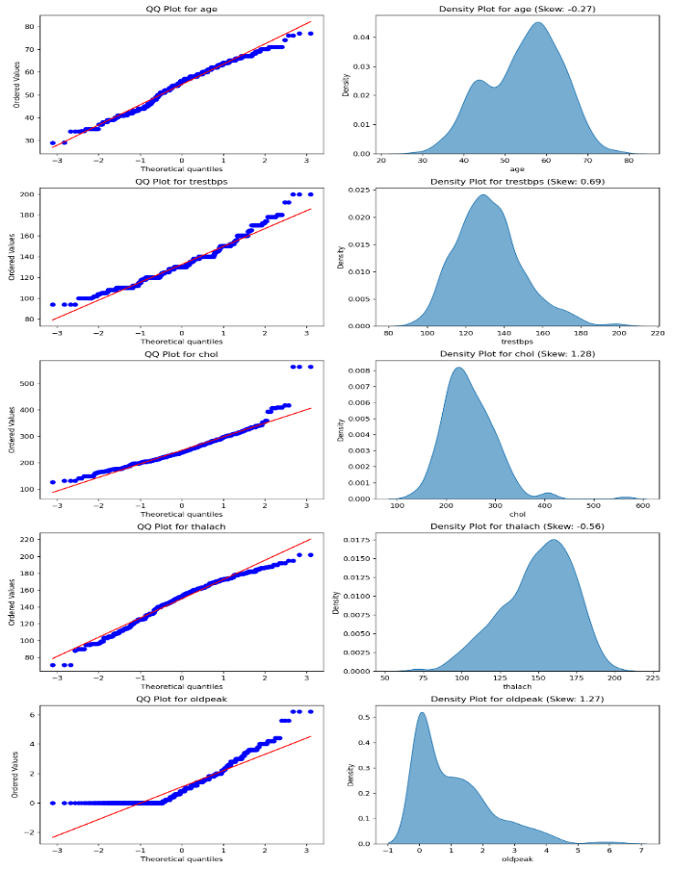

1. The QQ plots for age and chol variable show deviations at the tails, meaning the data isn’t perfectly normal. This could be due to outliers or skewness.
2. The QQ plot for thalach and trestbps are close to a straight line, so it’s more normally distributed compared to others.
3. The QQ plot for oldpeak deviates a lot from the straight line, showing it’s not normal. This matches its density plot, which is right-skewed.

**Density Plots**

1. age is slightly left-skewed (-0.27), meaning more younger people in the data.
2. thalach is moderately left-skewed (-0.56), indicating an imbalance in the target variable (more of one class than the other).
3. oldpeak is highly right-skewed (1.27), with most values on the left and a long tail to the right.

**4.6 Transformation**

**4.6.1 Yeo-Johnson transformation on highly skewed features**

To address the skewness in the data, transformations were applied to the highly skewed features (|skewness| > 1). The Yeo-Johnson transformation was chosen because it can handle both positive and negative value. Since absolute skewness of oldpeak and chol are > 1, we will transform them.

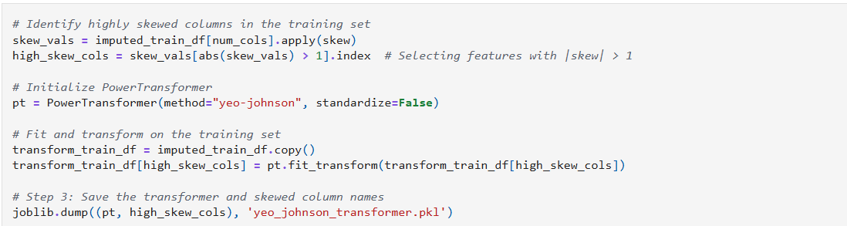

- After applying fit_transform to the training set, we saved the transformer for future reference. This ensures that the same transformation can be applied consistently to real  
testing data using transform.

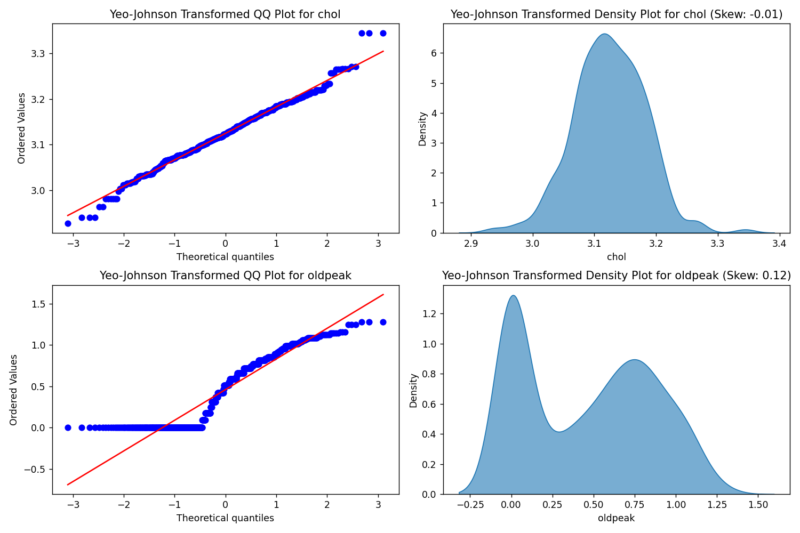

After applying the Yeo-Johnson transformation, the skewness of the highly skewed features (e.g., oldpeak and chol) was significantly reduced. This improvement brings the data closer to a normal distribution, making it more suitable for analysis and modeling.

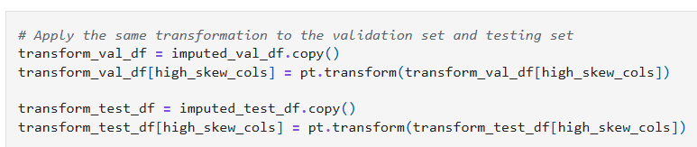

The same Yeo-Johnson transformation applied to the training set will also be applied to the testing and validation sets. This ensures consistency in data preprocessing and avoids data leakage, maintaining the integrity of the model evaluation process.

**4.6.2 Standardization for numerical features**

To ensure all numerical features are on the same scale, standardization was applied. The purpose of standardization also serves for outlier detection. However, for our cases, we will keep the outliers instead of removing it.

The key reason that we decided to keep outliers:  
- The remaining data, including outliers, are valid and not faulty. They represent real-world variability.  
- If we remove outliers might make the model less capable of handling unseen data that falls outside the "normal" range. Keeping outliers ensures the model can generalize better to real-world scenarios, even when encountering extreme values.

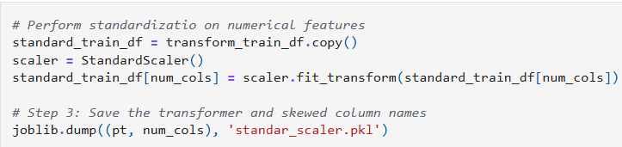

- We apply the same things like the transformation but now in terms of standardization

# Density plot of numerical features after standardized

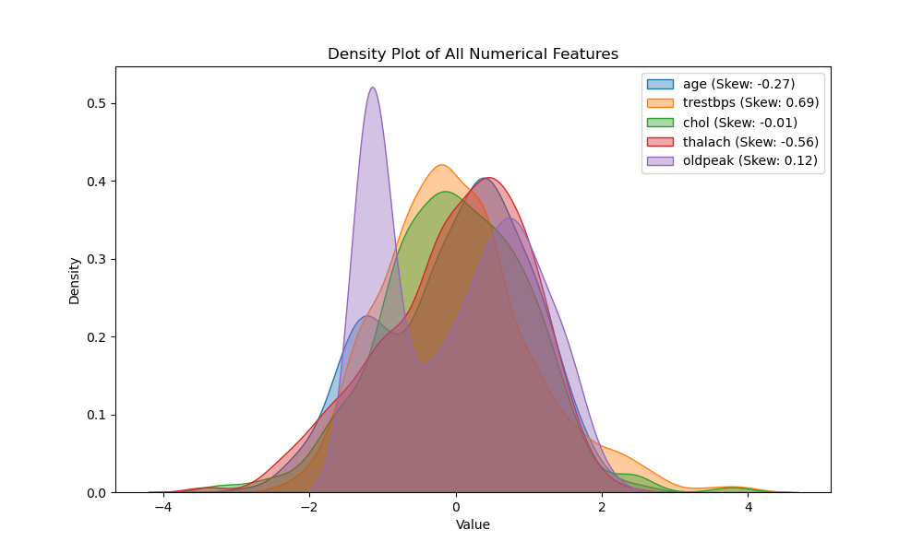

# Keep track of outliers

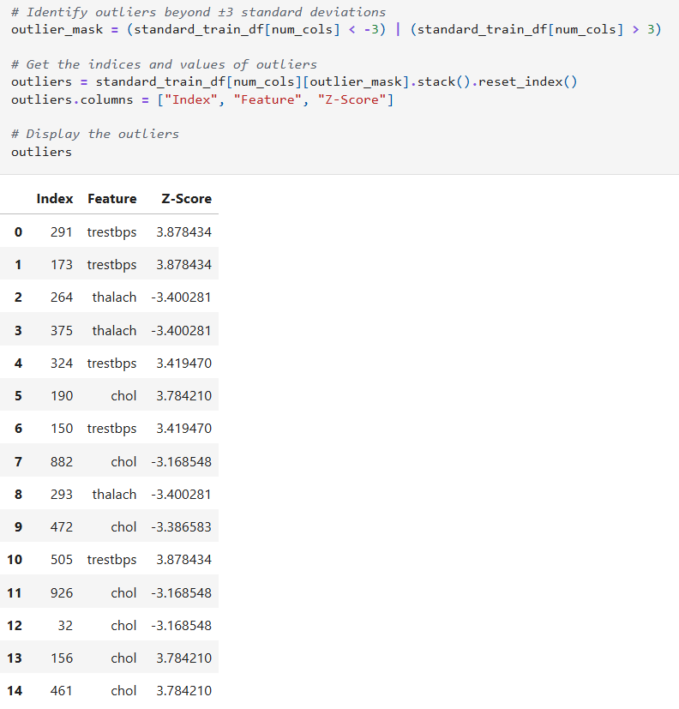

For transparency and further analysis, the outliers in the dataset have been identified and displayed. This allows for a deeper understanding of the data distribution and ensures that any extreme values are accounted for in the modeling process.

**4.6.3 Label Encoding for Categorical Features**

To handle categorical features in the dataset, label encoding was applied for all the categorical variables. Label encoding is chosen because it keeps the feature space small and efficient as well as avoids unnecessary complexity. The label encoder transformers are saved for future use.

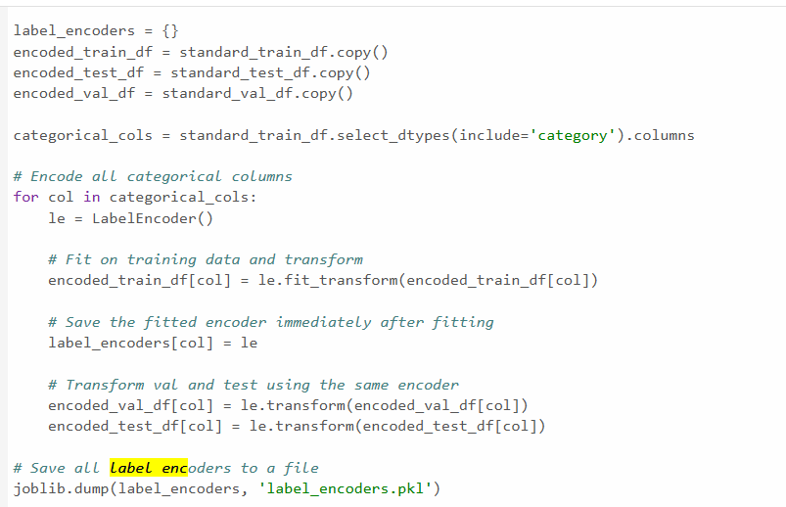

**4.7 Save preprocessed train, test and validate set into CSV**

the cleaned and pre-processed datasets for the training, testing, and validation sets were saved into separate CSV files. This saves time by avoiding the need to repeat for preprocessing steps in the future analyses.

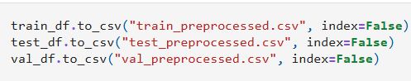

**5.0 MODEL CREATION**

**5.1 Model Training**

In the model training phase, we typically begin by training and assessing the performance of a **base model** using default parameters. This provides a benchmark to understand how well the algorithm performs out-of-the-box. Besides, we also assess the performance of a **hyperparameter-tuned model** using **Randomized SearchCV**, which allows for an efficient search over a range of possible parameter values. This step helps determine whether fine-tuning the model having better performance compared to based model. Randomized SearchCV is used for all the models as it is more efficient for large hyperparameters space, and it is more efficient in its computation. The number of folds for cross validation ranges from 3 to 5 due to small datasets. The reason why we didn’t consider GridSearhCV is because of it generally takes longer time to training a model and computationally expensive.

To evaluate the accuracy, we have used confusion matrix to identify the strength and weakness of the model through the type of error that it makes. A classification report is also printed out to evaluate the performance of the model. An ROC curve is also printed out for each model such that we can compare the model across the thresholds and select the best model. Finally, the feature importance for tree-based models is also displayed to identify which variable is the most influential in the model. We will be investigating 10 models which are KNN, SVM, Logistic Regression, Neural Network, Random Forest, XGBoost, Naïve Bayes, Decision Tree, Ada Boost and Gradient Boosting.

**5.1.1 K-Nearest Neighbors (KNN)**

KNN is a distance-based classification algorithm that assigns a class label based on the majority label of the K nearest neighbors in the feature space.

The first model tested is the K-Nearest Neighbors (KNN) classifier. The initial step involves identifying the optimal value for K.

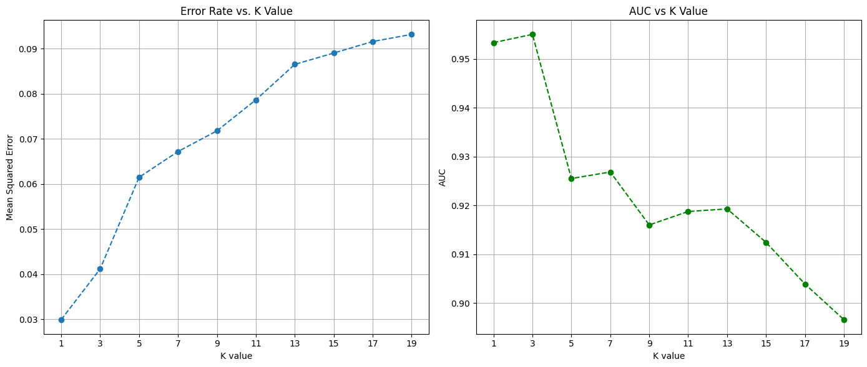

From the results, it is observed that both K = 1 and K = 3 yield the lowest error rates. However, we don’t consider K=1 since it is too sensitive to noise and has high variance. Besides, the AUC (Area Under the Curve) is highest when K = 3, indicating that the model performs best at this value. Hence, the K-NN model is trained with best k selected (K = 3).

# Before Tuning

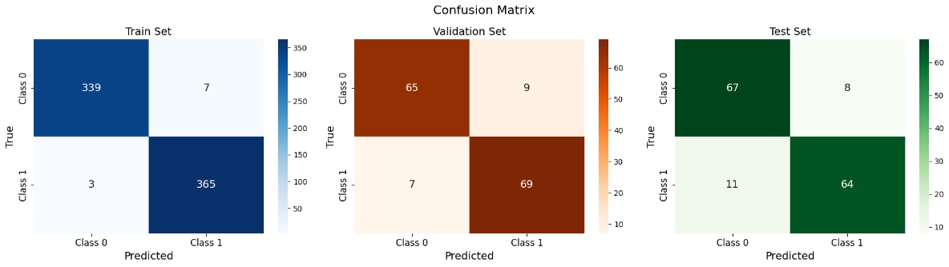

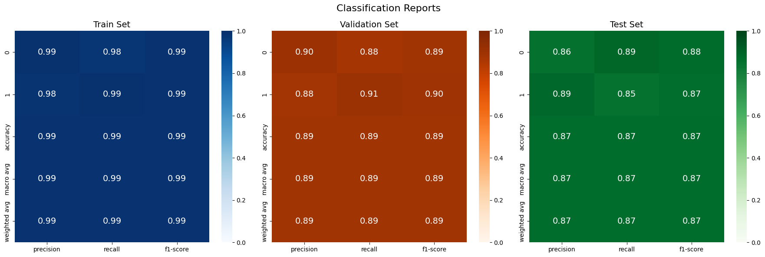

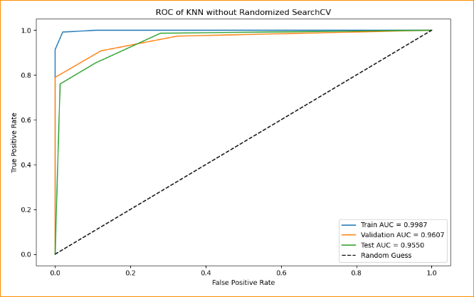

Before hyperparameter tuning, the confusion matrices and classification reports show that the model performs almost perfectly on the training set, suggesting possible overfitting. While there is a slight drop in performance for the validation and test sets, the model still performs well overall.

# After Tuning

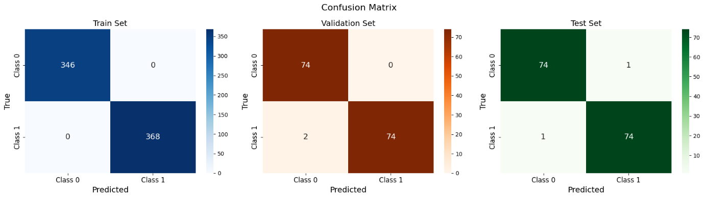

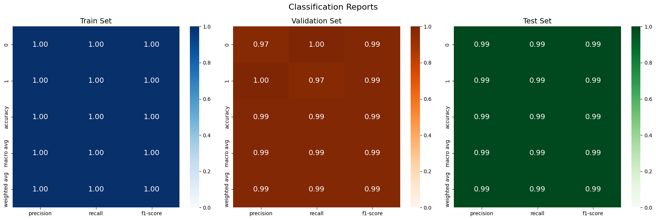

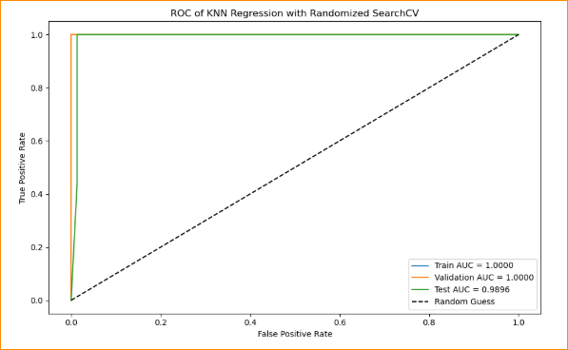

After applying hyperparameter tuning using Randomized SearchCV, the performance across all three sets (training, validation, and test) improves further. The confusion matrices and AUC curves show near-perfect scores, indicating excellent generalization, high precision, and a well-balanced model with reduced risk of overfitting.

**5.1.2 SVM (Support Vector Machines)**

The Support Vector Machine (SVM) is a supervised machine learning algorithm widely used for classification tasks. Its primary objective is to find the optimal hyperplane that best separates the data into classes by maximizing the margin between the support vectors — the data points closest to the decision boundary.

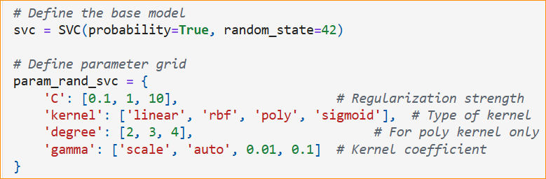

# Best parameters After tuning

We tested four types of kernels (linear, rbf, poly, and sigmoid) in the parameter grid. After tuning with Randomized SearchCV, we found that the **rbf** **kernel** performed the best based on the cross-validation AUC score. This suggests that **rbf** was able to model the data's non-linear patterns effectively.

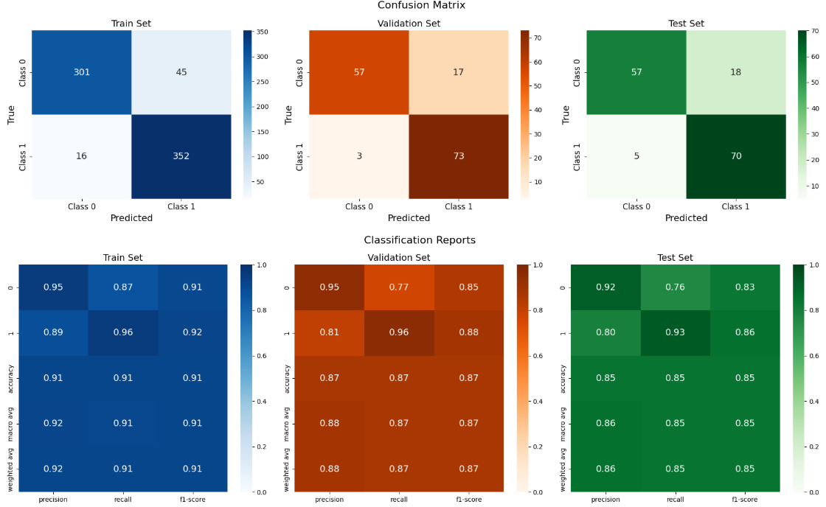# Before Tuning

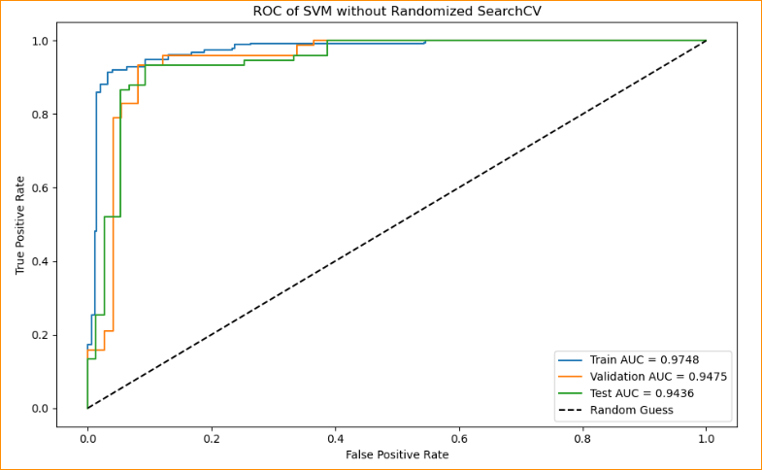

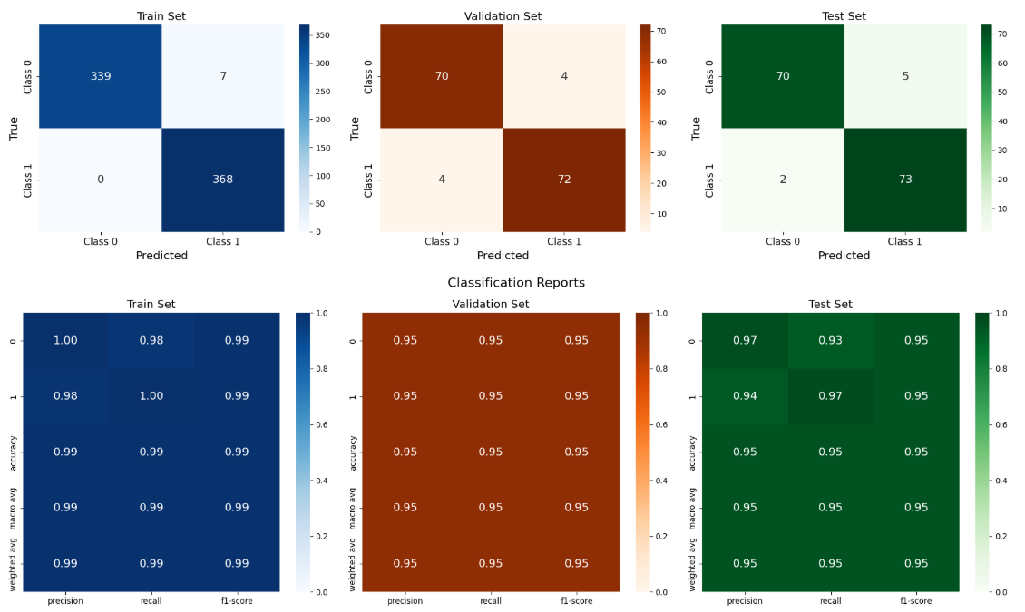# After Tuning

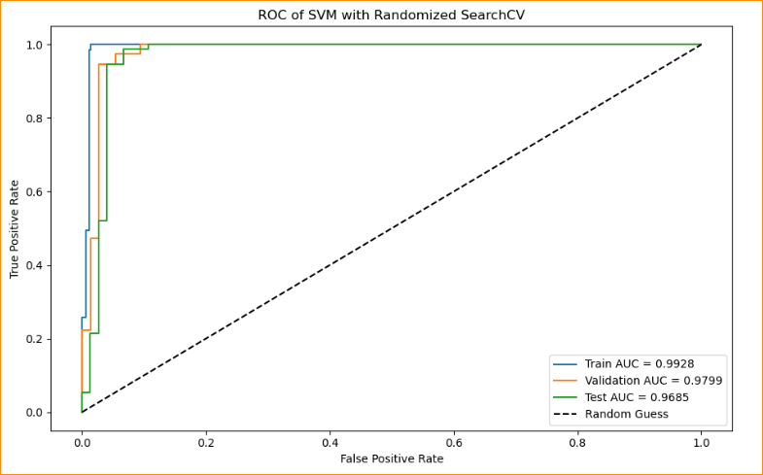

As shown in the diagram, the confusion matrices and classification reports before tuning reveal high accuracy on the training set, but slightly lower performance on the validation and test sets. This indicates a potential issue with overfitting. After applying hyperparameter tuning with Randomized SearchCV, the model's performance improves significantly. Accuracy across all three sets exceeds 95%, and the ROC curves show noticeable improvements, indicating enhanced generalization capability.

**5.1.3. Logistic Regression**

Logistic Regression is a supervised learning algorithm commonly used for binary classification problems, making it well-suited for the heart disease dataset where the target variable is either 0 (no disease) or 1 (disease). While it shares similarities with Linear Regression, Logistic Regression differs in that it predicts probability and maps the output to a binary value using the sigmoid function.

# Before Tuning

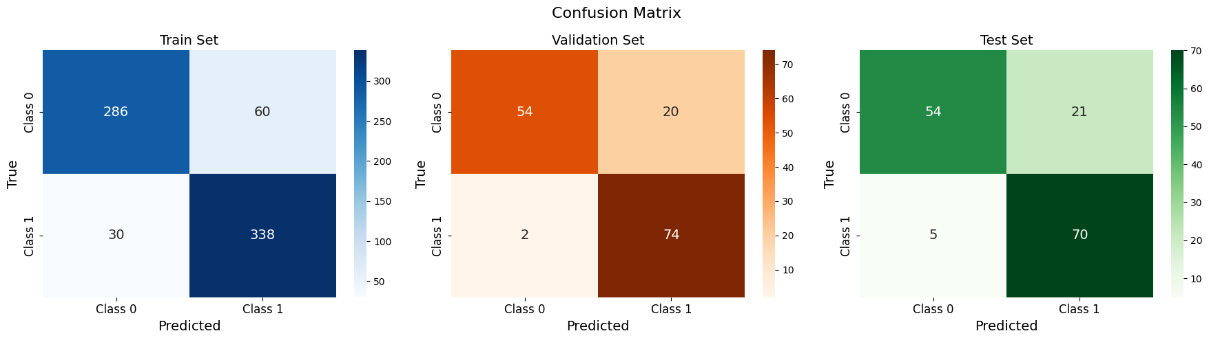

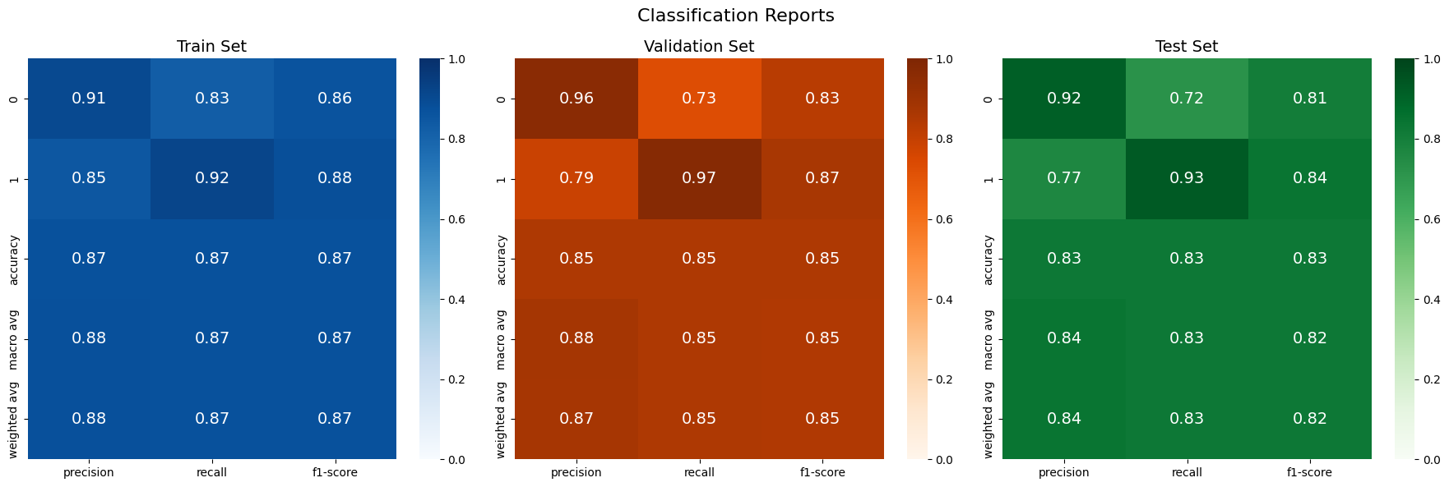

From the initial results (before tuning), the confusion matrix shows accuracies of:

* 87% on the training set
* 85% on the validation set
* 82% on the test set

These values are relatively close to one another, indicating reasonable generalization, although there's still room for improvement.

# After Tuning

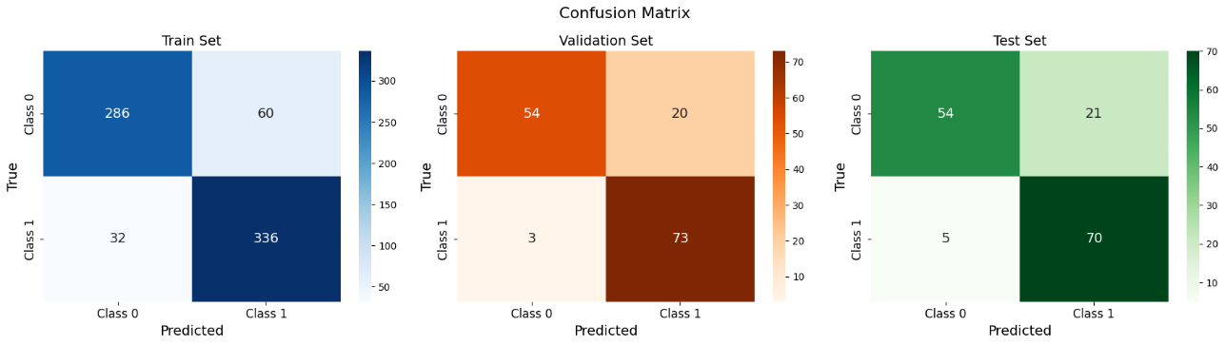

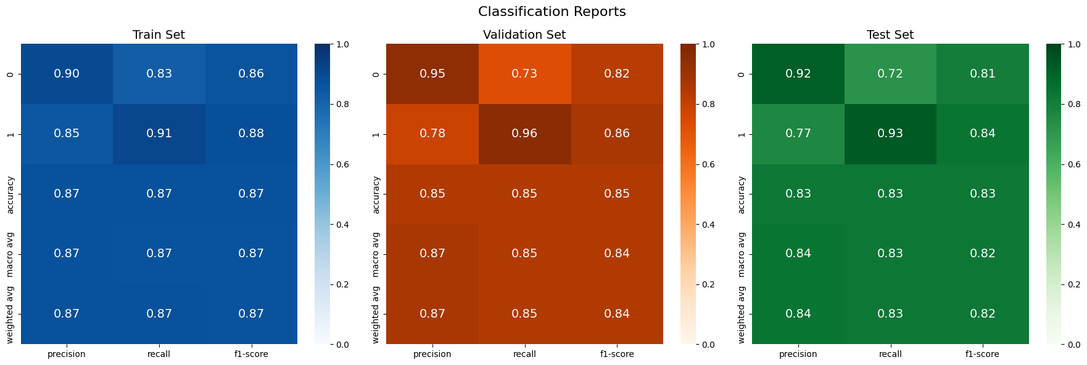

After applying hyperparameter tuning with Randomized SearchCV, the updated confusion matrices still show similar accuracy as before tuning. This suggests that Logistic Regression might not be the best-performing model for the heart disease dataset. Even though categorical encoding was applied, it only helps the model interpret the data — it does not make the linear model inherently smarter. Since heart disease prediction is likely a non-linear problem, more complex models may be better suited to capture the underlying patterns in the data. The ROC curve below also reflects the issue.

# ROC curve Before Tuning

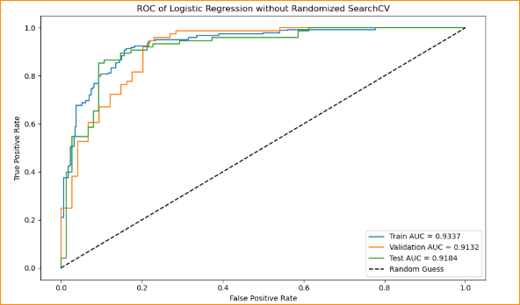

# ROC curve After tuning

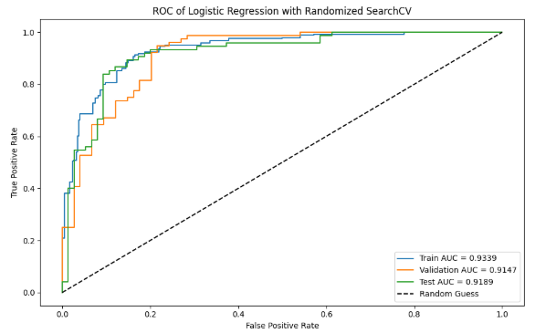

**5.1.4. Naive Bayes**

The Naive Bayes classifier is a probabilistic model based on Bayes’ Theorem, which uses the concept of conditional probability — the likelihood of an event occurring given that another event has already occurred. In the context of this dataset, the model predicts the likelihood of heart disease based on features such as high cholesterol levels or chest pain type. Since the Naïve Bayes only have few parameters, the result before tuning and after tuning are almost the same.

# Confusion matrix before Tuning and after Tuning

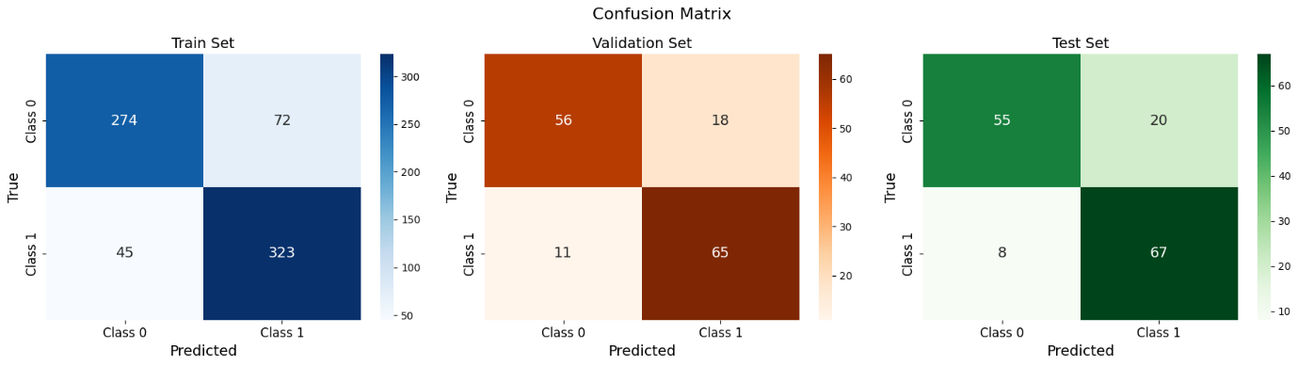

# Classification reports before tuning and after tuning

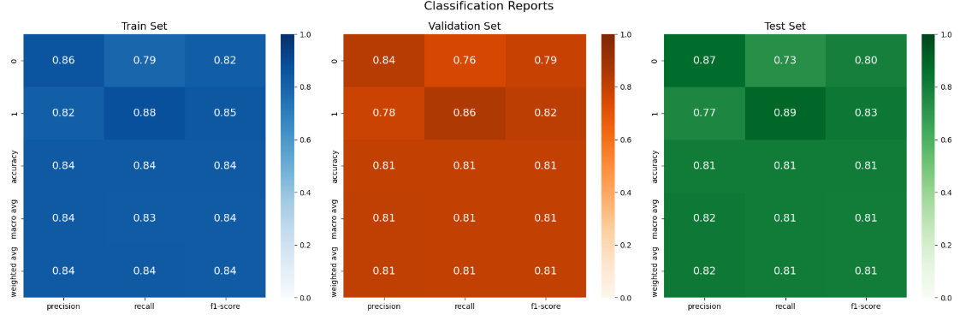

# ROC curve before and after tuning

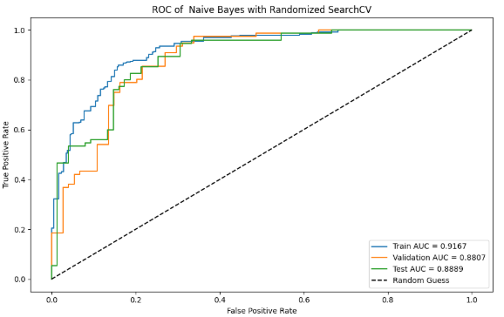

Confusion matrices, classification reports, and ROC curves show minimal difference before and after applying Randomized SearchCV. This may suggest that the base model already performs well with default parameters, or it could indicate that the training data is insufficient to benefit from further tuning.

Additionally, Naive Bayes inherently has very few hyperparameters (primarily the smoothing parameter alpha). Since the model is built on strong assumptions like feature independence, tuning often yields only marginal improvements or not many improvements. In such cases, it may be beneficial to explore alternative models that can better capture complex, nonlinear relationships in the data.

**5.1.5. Neural Network**

The fifth model that we have selected is Neural Network. It works well with binary classification. It is generally hard to interpret and explain what happened inside it because of the ‘black box’ that exists within neural network. It can perform well but will require some tuning.

# Hyperparameters

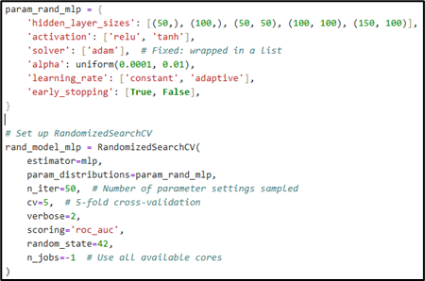

There are five different hidden layer configurations to try during tuning since our dataset is small.

# The best parameters we obtained after tuning the model

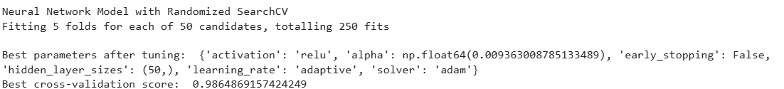

From the best parameters, **activation function (relu)** introduces that non-linearity and performs well in deep learning tasks. Next, A single hidden layer with 50 neurons provided a good balance between model complexity and training time.

# Neural Network Confusion Matrix (no changes between before tuning and after tuning)

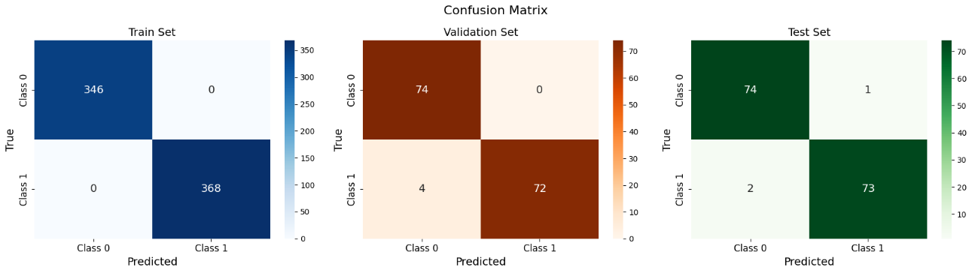

From the confusion matrix above, we see that there are no changes after tuning the model, suggesting no overfitting or underfitting issue and that the model is already well-tuned before applying Randomized SearchCV.

# Neural Network Classification Report (no changes before tuning and after tuning)

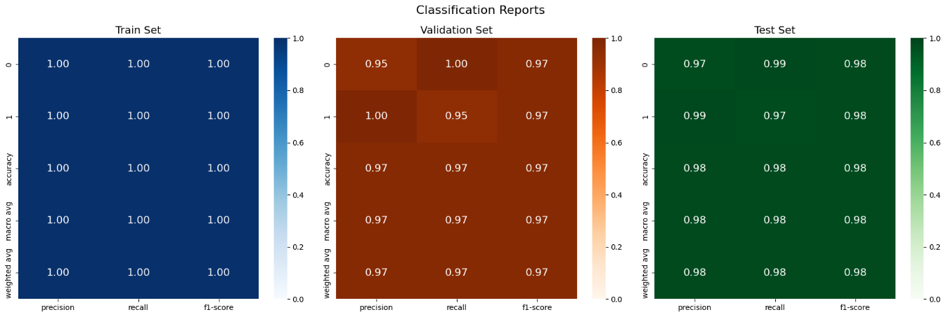

From the classification report above, there are also no changes which also suggest that the models are well-tuned

# ROC of Neural Network Model without Randomized SearchCV

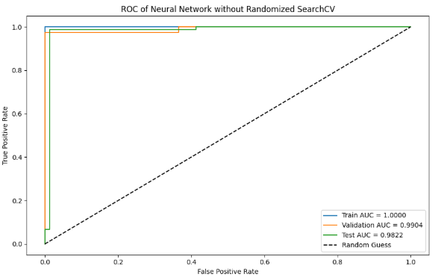

# ROC of Neural Network Model with Randomized SearchCV

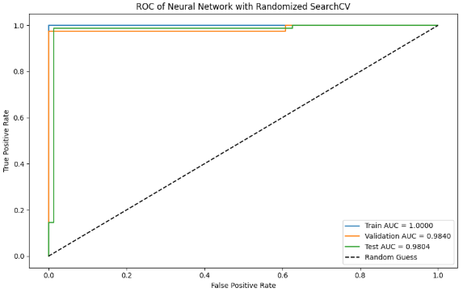

After tuning, the training AUC remained at 1.0, indicating the model fits the training set very well. However, a slight decrease in validation and testing AUC from 0.99 to 0.98 suggests that the model has better generalization and is less likely to overfit, thanks to the introduction of regularization and a simpler network structure.

**5.1.6. Decision Tree**

In the context of heart disease prediction, a Decision Tree model works by recursively selecting the most informative features to split the data. For example, the model may first split based on the chest pain type (cp) — if it's the most significant predictor — and continue selecting the next best features at each branch. This process continues until a leaf node is reached, which provides a prediction: whether the patient has heart disease (1) or not (0).

# Before Tuning

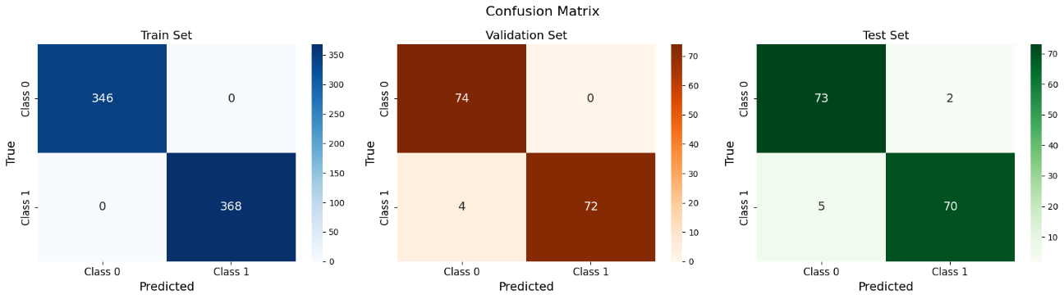

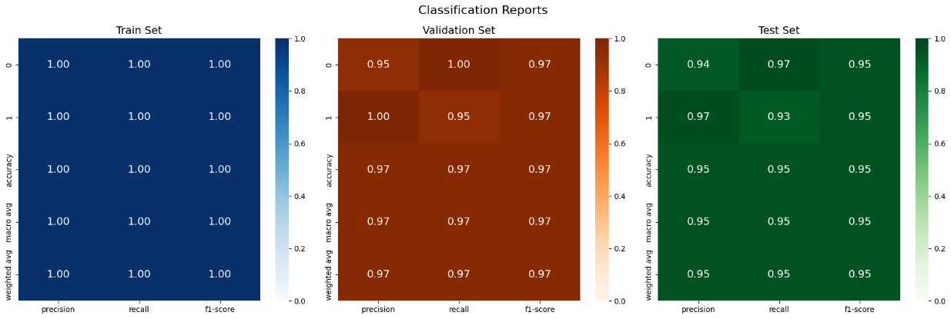

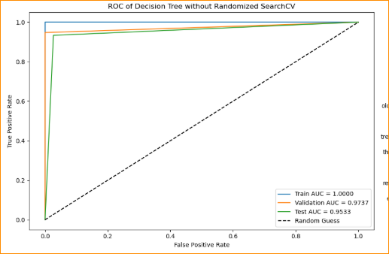

# Before Tuning

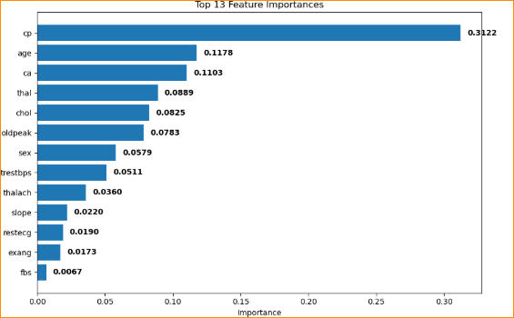

An analysis of feature importance before tuning reveals that the cp feature dominates significantly, with a much higher importance score than the rest. This suggests that the model may be over-relying on a single feature, potentially ignoring the broader patterns captured by other features.

# After Tuning

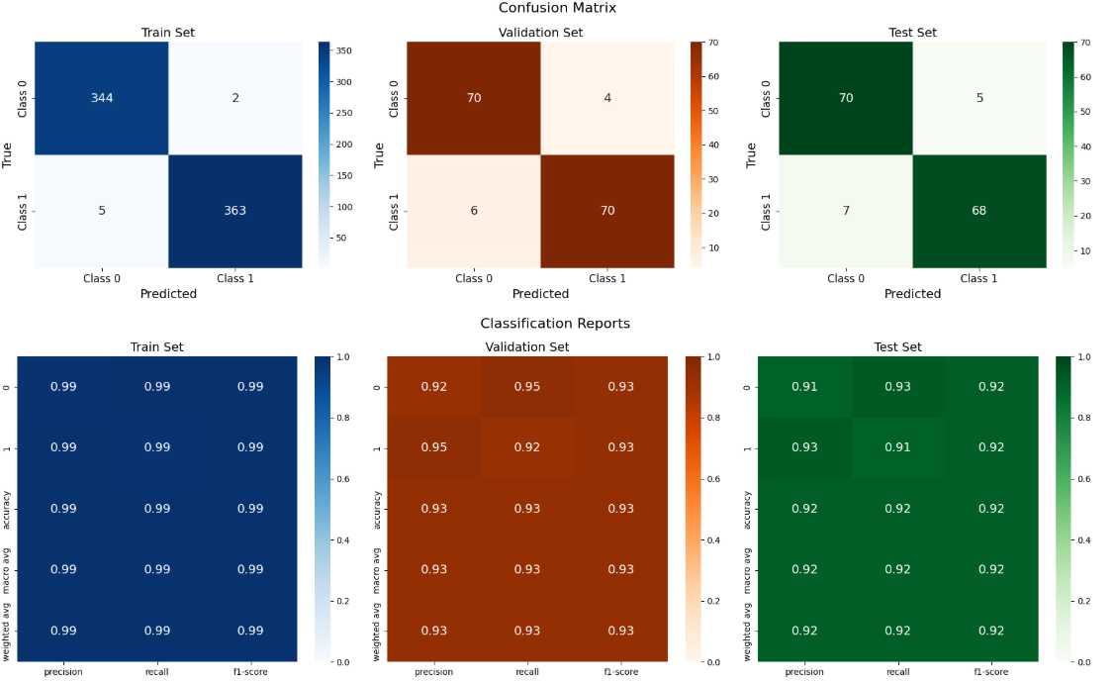

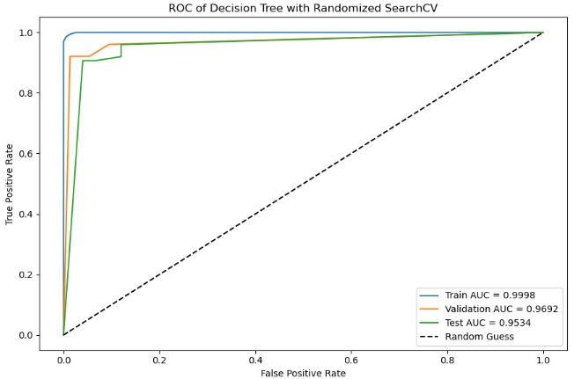

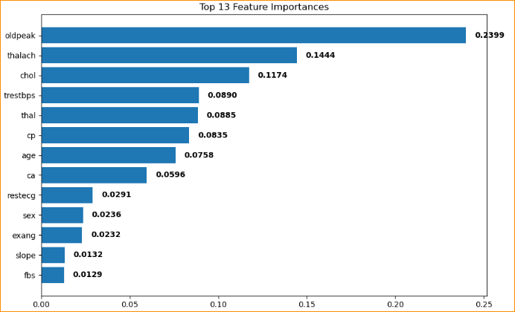After applying Randomized SearchCV for hyperparameter tuning the gap in feature importance narrows, meaning the model is now relying on a broader set of features rather than one dominant feature. This reflects a more balanced and robust understanding of the underlying data.

**5.1.7. Random Forest**

The seventh model that we have used is random forest. This model was chosen because it works well with binary classification. Random forest is not as easy to interpret like other model such as knn or logistic regression model. In terms of performance, it usually has high accuracy and AUC score as well as being robust to noises and overfitting. The following are the parameters that have we have decided to use for Randomized Search CV

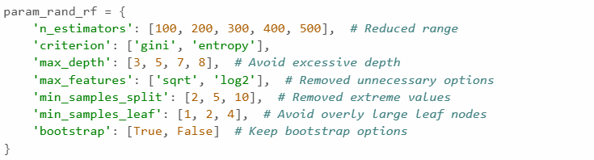# Parameters for Randomized SearchCV for random forest

* To prevent overly complex models, the maximum depth of trees (max_depth) is restricted between 3 and 8. Overall, this setup aims to make hyperparameter tuning faster and more effective while avoiding overfitting and unnecessary complexity.

# Confusion Matrix before Tuning

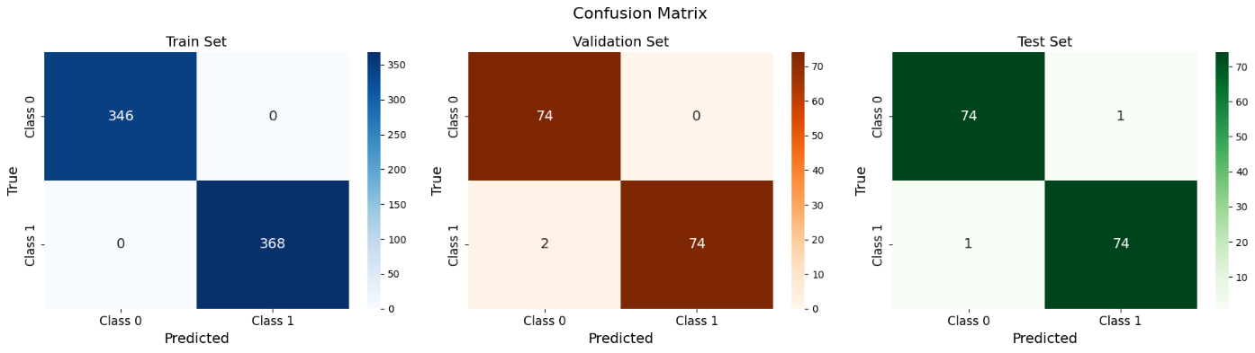# Confusion Matrix after Tuning

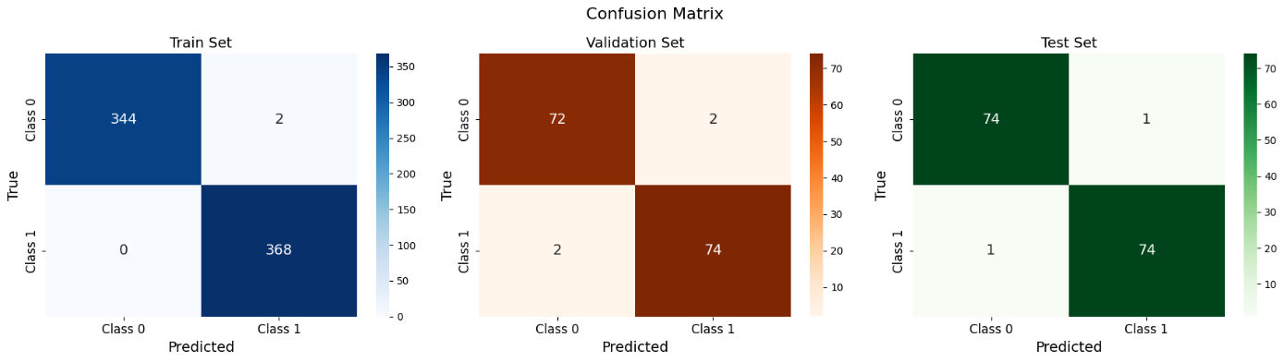

# Classification Report before Tuning

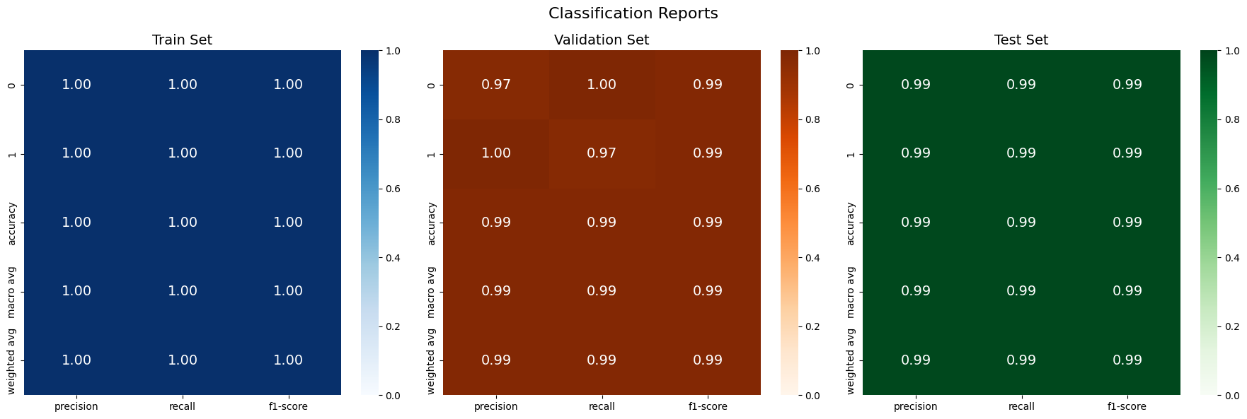

# Classification Report after Tuning

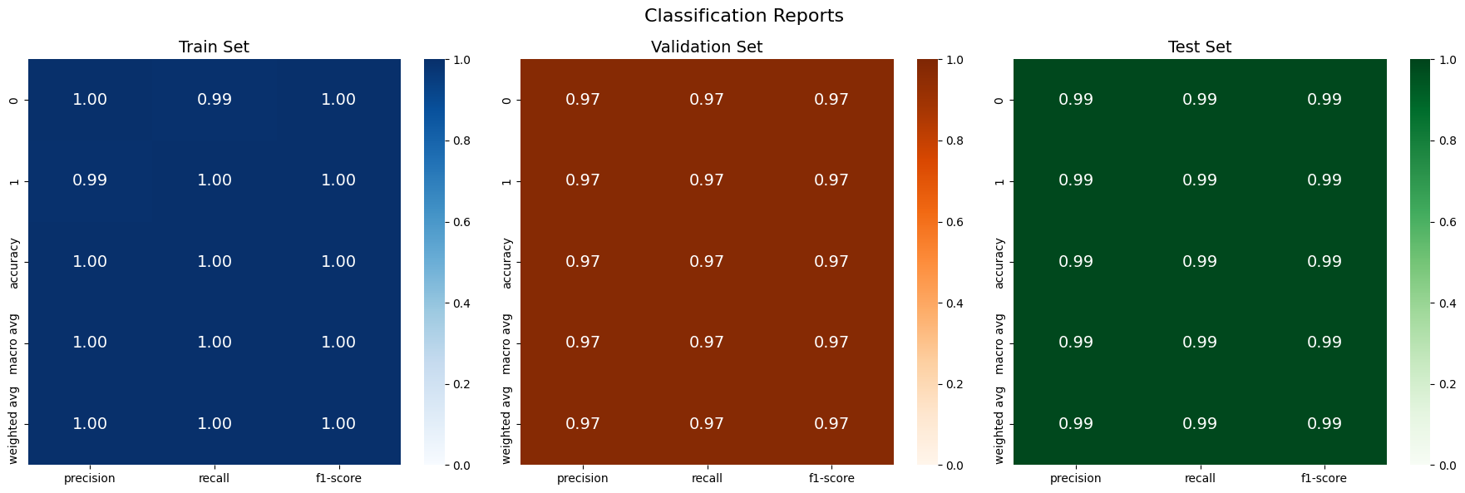

From both confusion matrix, we see that the accuracy for the training set and validation set is better without tuning the model with Randomized SearchCV. For both the training set and validation set, the false positive (FP) amount increased by 2 after tuning the model with Randomized search CV. This suggests that either the default parameters are already very well-suited and there exist little to no overfitting or underfitting issue. There is no difference in the Test set before and after tuning.

# ROC curve before Tuning

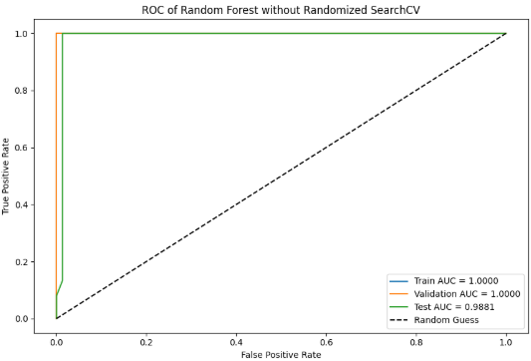

# ROC curve after Tuning

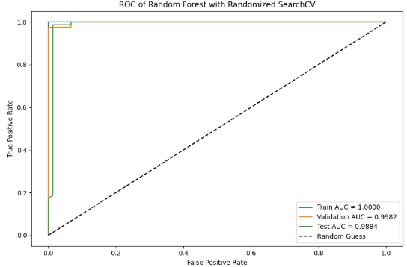

From both the ROC curve, we see that the AUC of both training set is at 1. For the AUC of validation set, it has a perfect score before tuning and a minimal drop of 0.18% which we can ignore as it is still very high. For the AUC of test validation, there is a slight increase of 0.03% after the model has been tuned. From this, we can confirm that there our previous assumption where there are little to no overfitting issues.

# Random Forest Feature Importance without Randomized SearchCV

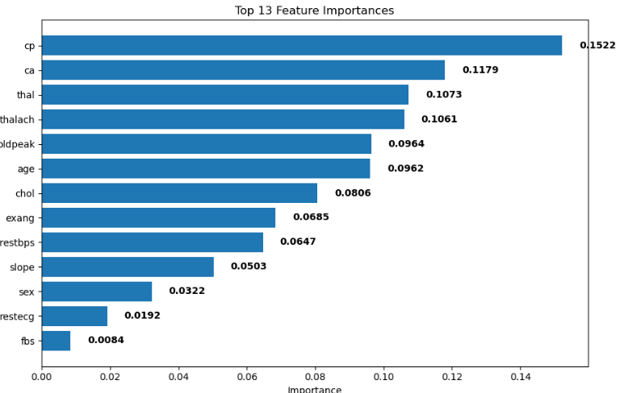# Random Forest Feature Importance without Randomized SearchCV

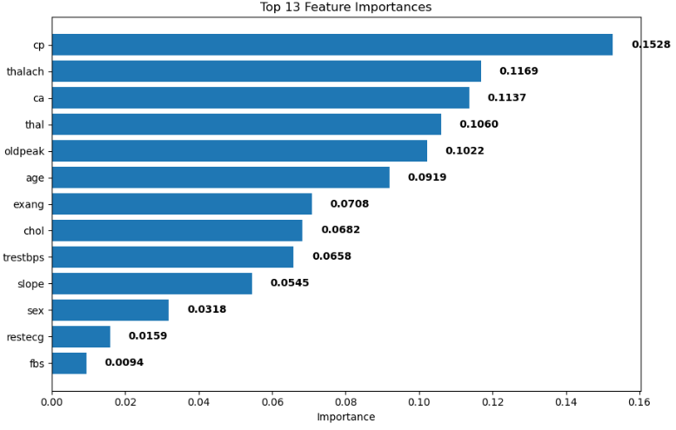

From both features’ importance ranking above, we see that cp remains the highest while fbs remains the lowest after tuning. After tuning the model, we see that thalach has risen from fourth place to the second place. The refined model is much more efficient as it eliminates noise from the weaker predictors.

**5.1.8. XG Boost**

The eighth model that we have used is XG Boost. It is selected as it works well with binary classification. In terms of interpretability, XG boost is harder to interpret. In terms of performance, it is considered one of the best for binary classification tasks. However, this model is highly sensitive to the hyperparameters value and so tuning is required. The following are the parameters that we have used for randomized search CV

# Parameters for Randomized SearchCV for XG Boost

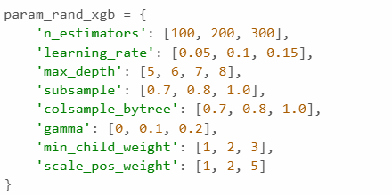

* max_depth, which controls the complexity of each tree with values from 5 to 8 since our datasets are small, and learning_rate, which adjusts how quickly the model learns, tested at 0.05, 0.1, and 0.15. Tuning these helps balance model accuracy and overfitting

# XG Boost Confusion Matrix Without Randomized Search CV

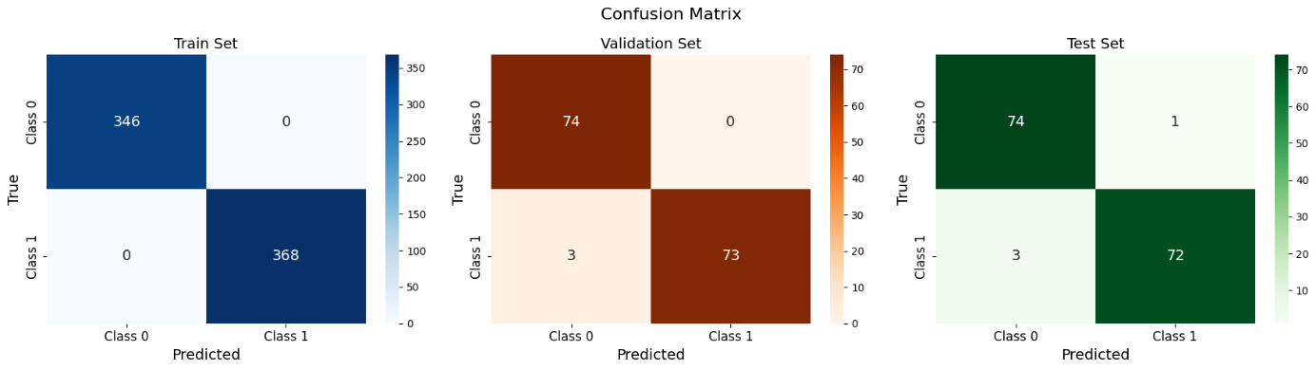

# XG Boost Confusion Matrix With Randomized Search CV

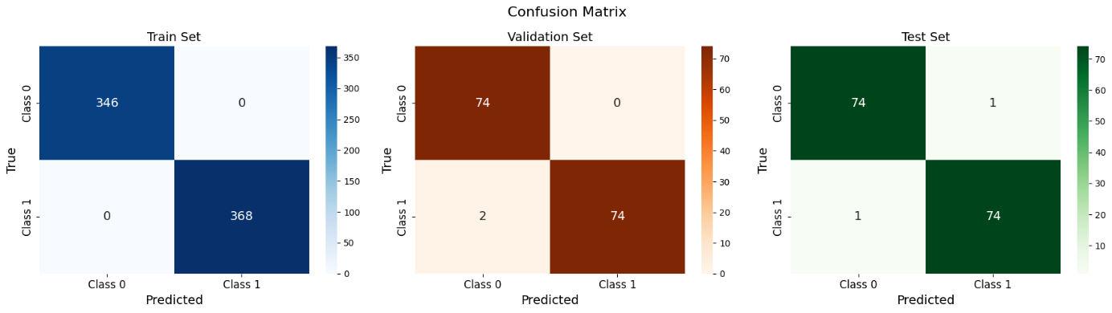

From both confusion matrices above, we see that there is no changes in the training set, there is a decrement of 1 in FN of validation set after tuning and decrement of 2 in FN for test set as well. The minimal changes suggest that no overfitting or underfitting issue exists.

# XG Boost Classification Report Without Randomized Search CV

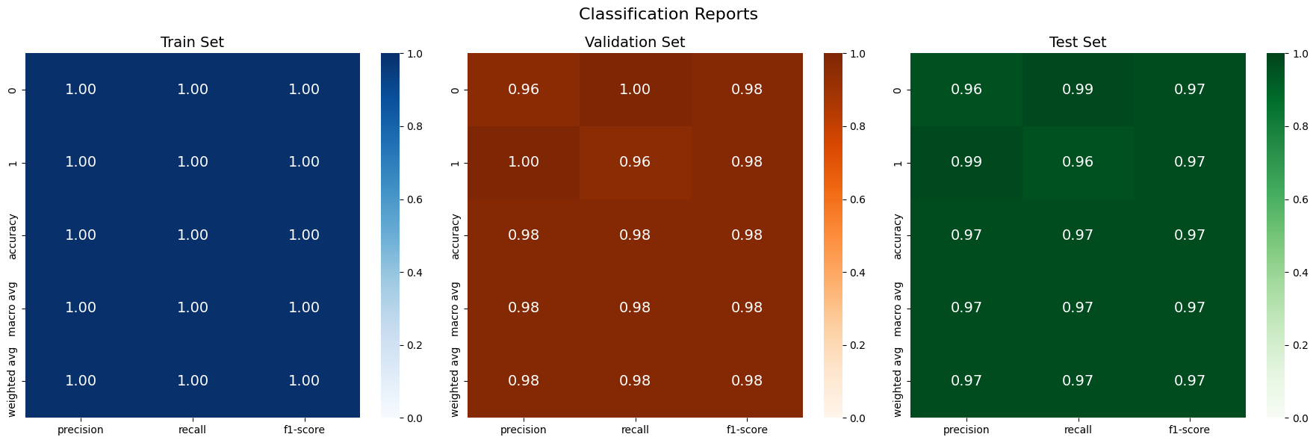

# XG Boost Classification Report With Randomized Search CV



From both classification reports above, there are no changes in the training and validation set. There is a slight increase of 0.01 across the validation set and a slight increase of 0.02 for testing set. Minimal changes above suggest no overfitting or underfitting issue.

# ROC of XG Boost Model without Randomized SearchCV

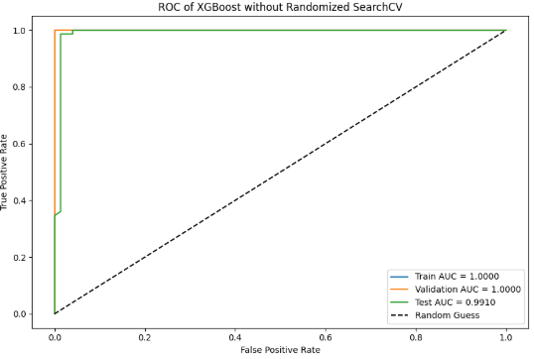

# ROC of XG Boost Model with Randomized SearchCV

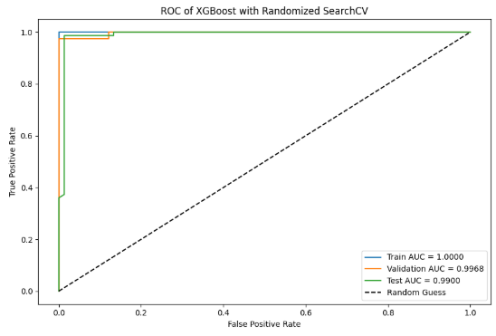

From both ROC curves, we see that there are no changes in the AUC for the training data, which suggests that it is perfect. For the AUC of validation, there is a decrease of 0.32%. For the AUC of test data, there is also a slight decrease in 0.10%. From the curve, we conclude that there is no overfitting or underfitting and that the model is already well-tuned

# XG Boost Feature Importance without Randomized SearchCV

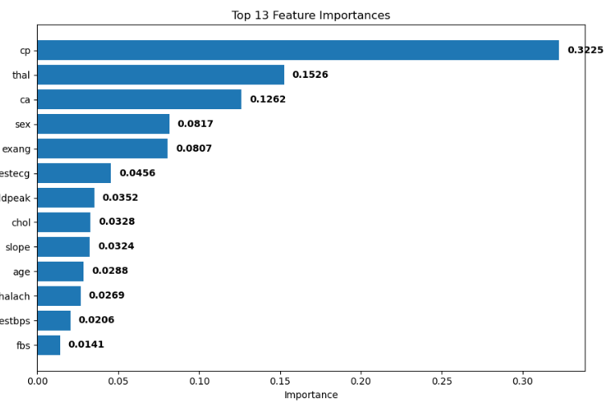

# XG Boost Feature Importance with Randomized SearchCV

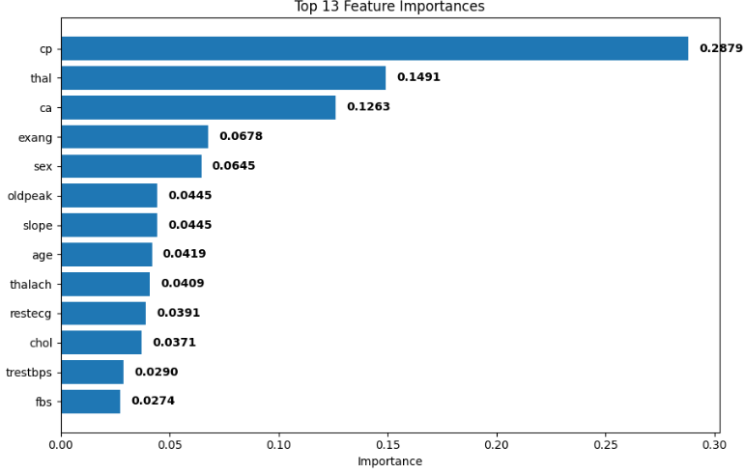

From the Feature importance ranking above, we see that there are only minimal changes

**5.1.9. ADA Boost**

The ninth model selected is ADA Boost. In terms of interpretability, it is more interpretable than XG Boost. This model also has good performance, but it can underperform if it is met with noisy data. The following are the parameters that we have used for randomized search CV

# Parameters for randomized SearchCV for ADA Boost

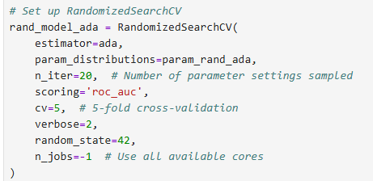

Unlike the previous model, we have set the number of iterations to be 20 because of its fewer hyperparameters to tune which makes it more efficient and practical.

# ADA Boost Confusion Matrix Without Randomized Search CV

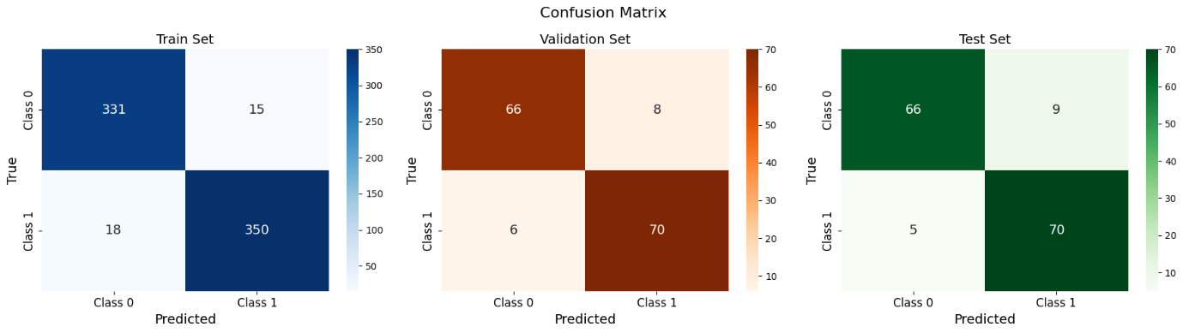

# ADA Boost Confusion Matrix with Randomized Search CV

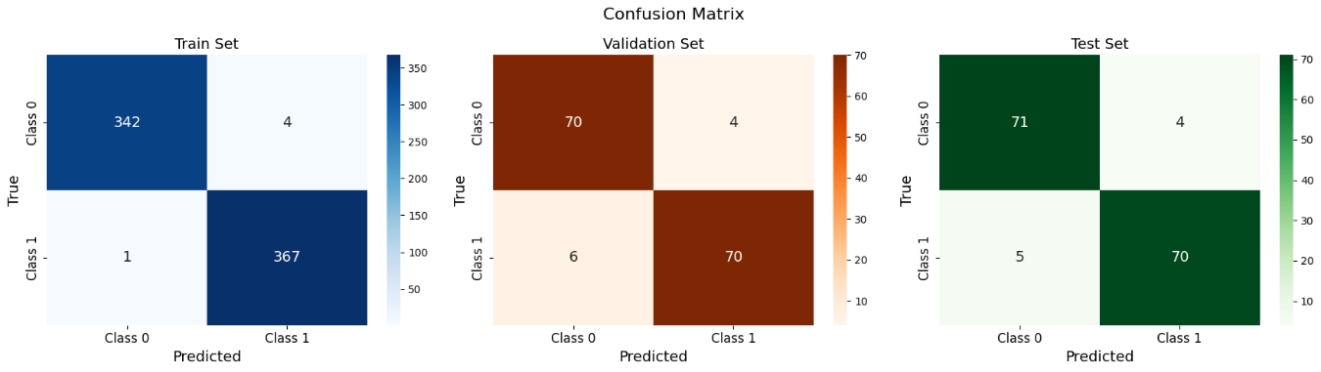

# ADA Boost Classification Report without Randomized Search CV

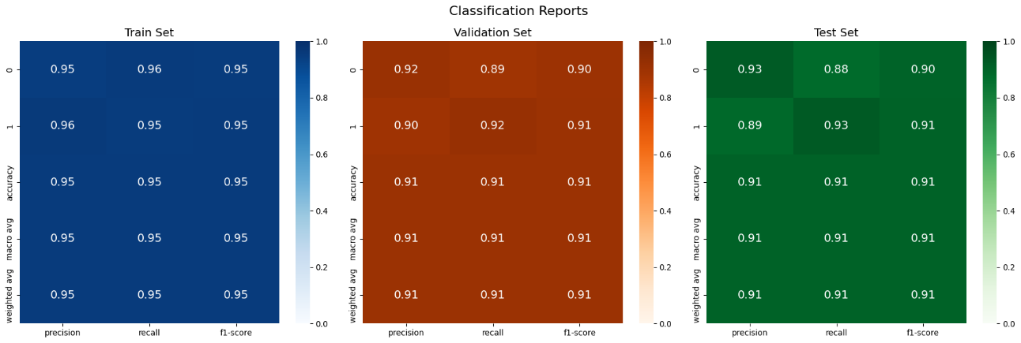

# ADA Boost Classification Report with Randomized Search CV

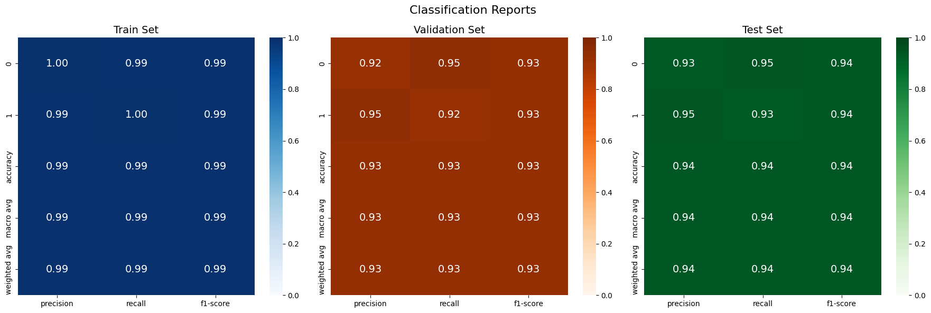

# ROC of ADA Boost Model without Randomized SearchCV

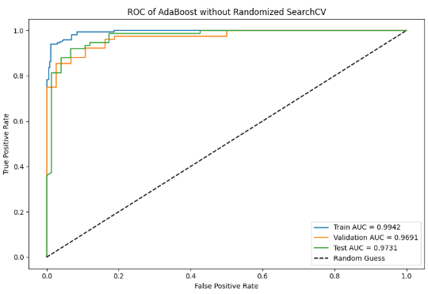

# ROC of ADA Boost Model with Randomized SearchCV

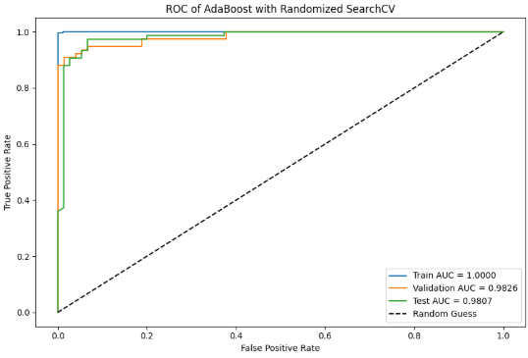

From the ROC curve, confusion matrix and classification report above, we see that the accuracy for all 3 sets increased. This shows that the tuning is effective.

# ADA Boost Feature Importance with Randomized SearchCV

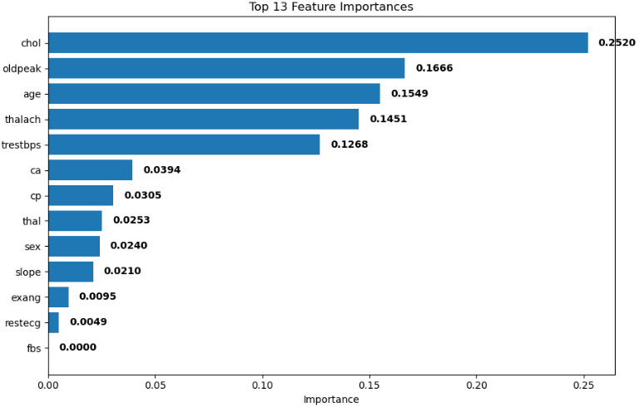

# ADA Boost Feature Importance without Randomized SearchCV

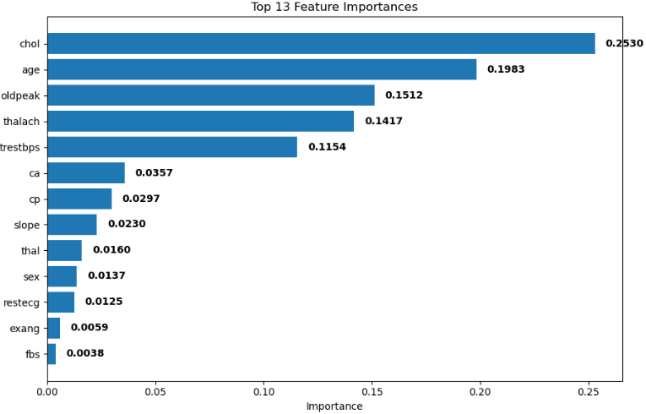

From the ranking of feature importance above, we see that chol is the most influential variable while fbs is the least influential variable. Age has replaced oldpeak in second place. Just like the few previous models we can see the gap between the highest features become narrow, prevents the feature dominance.

**5.1.10. Gradient Boosting**

The last model that we have selected is gradient boosting. It works well with binary classification. Its interpretability is like XG boost which are considered hard to interpret. It is a good model but is also more prone to overfitting when compared to XG Boost. The following are the parameters that we have used for Randomized SearchCV.

#Parameters for Randomized SearchCV for Gradient Boosting

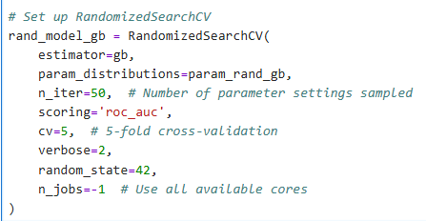

# Gradient Boost Confusion Matrix without Randomized Search CV

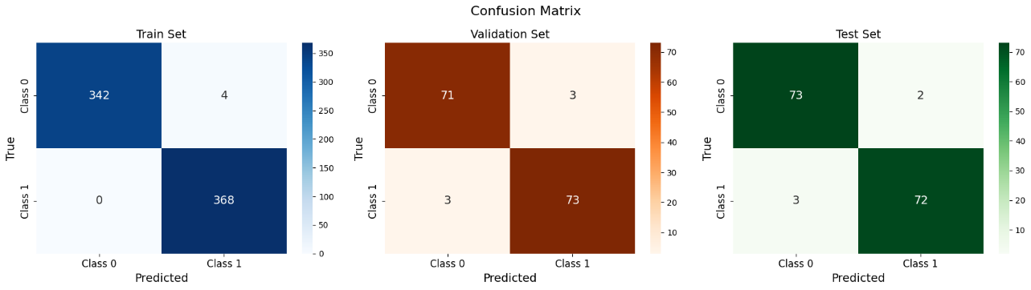

# Gradient Boost Confusion Matrix Without Randomized Search CV

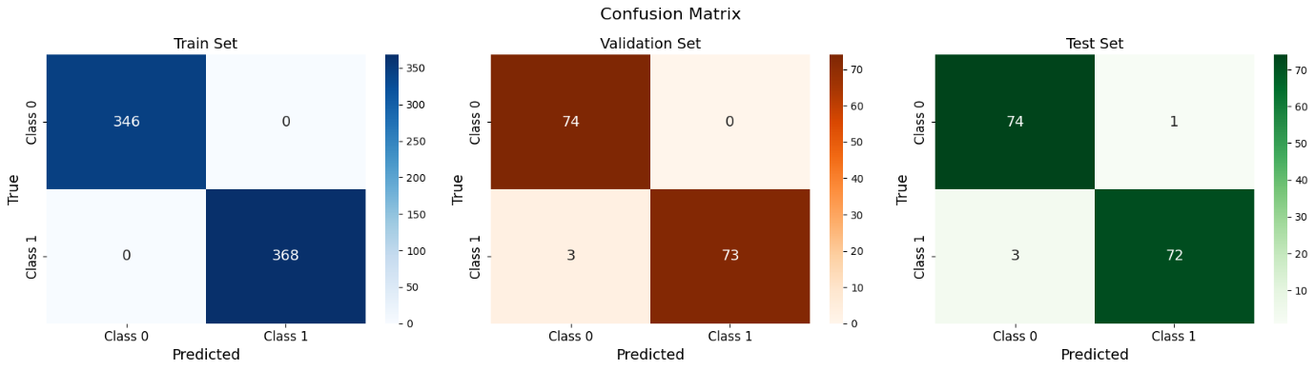

#Gradient Boosting Classification Report with Randomized Search CV

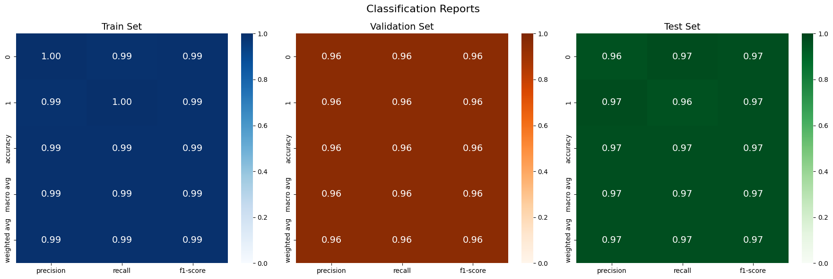

# Gradient Boosting Classification Report without Randomized Search CV



# ROC of Gradient Boosting Model without Randomized SearchCV

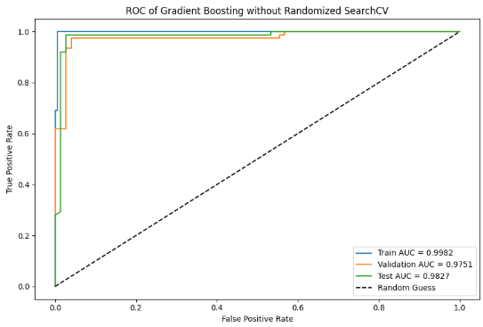

# ROC of Gradient Boosting Model with Randomized SearchCV

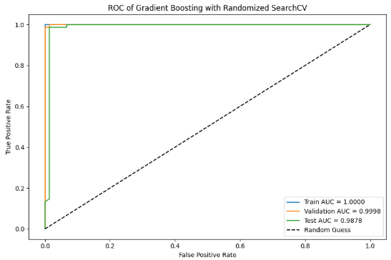

From the ROC curve , confusion matrix and classification report above, we see that the accuracy for all 3 sets increased. This shows that the tuning is effective.

# Gradient Boosting Feature Importance without Randomized SearchCV

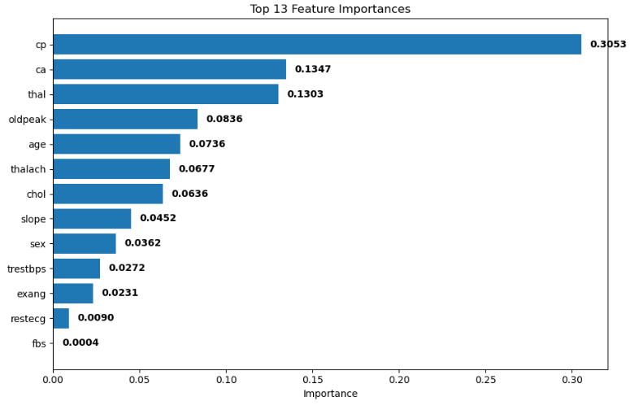

# Gradient Boosting Feature Importance with Randomized SearchCV

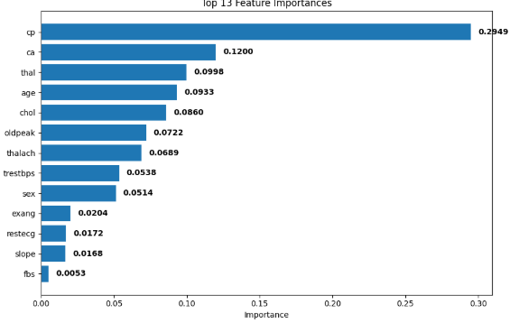

For the ranking of feature importance, we observe that 'cp' remains the most important feature even after tuning. Gradient Boosting tends to focus heavily on the most predictive features, especially in the early trees. If a feature like 'cp' strongly correlates with the target variable (presence or absence of heart disease), Gradient Boosting will prioritize splitting on it early in the process. This suggests that 'cp' is a highly useful feature, as we can see that its importance remains prominent, with the gap between its importance before and after tuning not narrowing significantly.

**5.1.11 Summarization of Feature Importances**

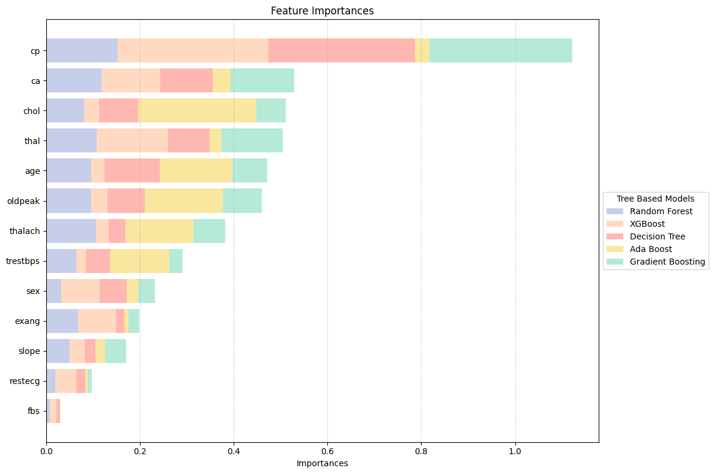

The figure above shows the feature importances across different tree-based models like Random Forest, XG Boost, Decision Tree and Gradient Boosting. The analysis reveals that **chest pain type (cp)** and **number of major vessels (ca)** are the most critical features, with near-maximum importance scores across all tree-based models.  This consistency suggests these features are robust predictors of heart disease.

**5.2 Model Evaluation and Comparison**

In model evaluation and comparison, we will use different evaluation matrices like confusion matrices, classification report, ROC curve and AUC score to compare the models. **All the** **evaluation metrices are based on testing sets**. When it comes to final model selection, we will be using ROC curve and AUC score (also known as area under the curve of ROC) to select the out-performed model.

**5.2.1 Comparison using Confusion matrix**

We will first be looking into the confusion matrix for testing set. Over here, we summarize all the true positive (TP), true negative (TN), false positive (FP) and false negative (FN) into a tabular form.

# Confusion matrix of testing set for **Based Model**

|  |  |  |  |  |
| --- | --- | --- | --- | --- |
| Model | True Positive (TP) | True Negative (TN) | False Positive (FP) | False Negative (FN) |
| KNN | 64 | 67 | 8 | 11 |
| SVM | 70 | 57 | 18 | 5 |
| Logistic Regression | 70 | 54 | 21 | 5 |
| Random Forest | 74 | 74 | 1 | 1 |
| XGBoost | 72 | 74 | 1 | 3 |
| Naive Bayes | 67 | 55 | 20 | 8 |
| Decision Tree | 70 | 73 | 2 | 5 |
| Neural Network | 73 | 74 | 1 | 2 |
| Ada Boost | 70 | 66 | 9 | 5 |
| Gradient Boosting | 72 | 73 | 2 | 3 |

# Confusion matrix of testing set for **Hyperparameter Tuning Model**

|  |  |  |  |  |
| --- | --- | --- | --- | --- |
| Model | True Positive (TP) | True Negative (TN) | False Positive (FP) | False Negative (FN) |
| KNN | 74 | 74 | 1 | 1 |
| SVM | 73 | 70 | 5 | 2 |
| Logistic Regression | 70 | 54 | 21 | 5 |
| Random Forest | 74 | 74 | 1 | 1 |
| XGBoost | 74 | 74 | 1 | 1 |
| Naive Bayes | 67 | 55 | 20 | 8 |
| Decision Tree | 68 | 70 | 5 | 7 |
| Neural Network | 73 | 74 | 1 | 2 |
| Ada Boost | 70 | 71 | 4 | 5 |
| Gradient Boosting | 72 | 74 | 1 | 3 |

The confusion matrix results show clear improvements in model performance after hyperparameter tuning, especially in reducing false positives (FP) and false negatives (FN).

Top Performing Models (Post-Tuning):

* **KNN, Random Forest, and XGBoost** achieved near-perfect classification with **TP = 74**, **TN = 74**, and only **1 FP and 1 FN**, showing excellent balance in both sensitivity and specificity.
* **Neural Network** also remained strong with just **1 FP and 2 FN**, maintaining high accuracy and reliability.

Notable Improvements:

* **KNN** had a substantial improvement, reducing FN from 11 to 1 and FP from 8 to 1.
* **SVM** reduced its FP significantly (from 18 to 5) and FN (from 5 to 2), reflecting better overall discrimination.

Consistent Performers:

* **Random Forest and Neural Network** maintained strong confusion matrix values pre- and post-tuning, showing robustness even without parameter adjustments.

Limited or No Improvement:

* **Logistic Regression** and **Naive Bayes** had unchanged confusion matrices, again highlighting their limited capacity to improve through tuning.
* **Decision Tree** slightly regressed post-tuning, increasing both FP and FN.

Conclusion:

Hyperparameter tuning significantly enhanced classification performance for several models—especially **KNN, XGBoost, and SVM**—by minimizing misclassifications. Ensemble models and neural networks consistently delivered high precision, confirming their effectiveness in handling complex classification tasks.

**5.2.2 Classification report (Weighted) & ROC-AUC**

Next, we will investigate the classification report in weighted based for testing set along with ROC-AUC. The weighted average calculates each metric by taking the support (number of true instances) of each class into account. This ensures that the overall score reflects the contribution of each class proportionally, rather than giving equal weight to all classes regardless of size. Even our dataset target’s variable is balanced, using the weighted average helps maintain consistency in evaluation.

# Classification report & ROC-AUC of testing set for **Based Model**

|  |  |  |  |  |  |
| --- | --- | --- | --- | --- | --- |
| Model | Accuracy | Precision | Recall | F1-score | ROC-AUC |
| KNN | 0.8733 | 0.8739 | 0.8733 | 0.8733 | 0.955 |
| SVM | 0.8467 | 0.8574 | 0.8467 | 0.8455 | 0.9436 |
| Logistic Regression | 0.8267 | 0.8422 | 0.8267 | 0.8247 | 0.9184 |
| Random Forest | 0.9867 | 0.9867 | 0.9867 | 0.9867 | 0.9881 |
| XGBoost | 0.9733 | 0.9737 | 0.9733 | 0.9733 | 0.991 |
| Naive Bayes | 0.8133 | 0.8216 | 0.8133 | 0.8121 | 0.8889 |
| Decision Tree | 0.9533 | 0.9541 | 0.9533 | 0.9533 | 0.9533 |
| Neural Network | 0.98 | 0.9801 | 0.98 | 0.98 | 0.9822 |
| Ada Boost | 0.9067 | 0.9078 | 0.9067 | 0.9066 | 0.9731 |
| Gradient Boosting | 0.9667 | 0.9667 | 0.9667 | 0.9667 | 0.9827 |

# Classification report & ROC-AUC of testing set for **Hyperparameter Tuning Model**

|  |  |  |  |  |  |
| --- | --- | --- | --- | --- | --- |
| Model | Accuracy | Precision | Recall | F1-score | ROC-AUC |
| KNN | 0.9867 | 0.9867 | 0.9867 | 0.9867 | 0.9896 |
| SVM | 0.9533 | 0.9541 | 0.9533 | 0.9533 | 0.9685 |
| Logistic Regression | 0.8267 | 0.8422 | 0.8267 | 0.8247 | 0.9189 |
| Random Forest | 0.9867 | 0.9867 | 0.9867 | 0.9867 | 0.9884 |
| XGBoost | 0.9867 | 0.9867 | 0.9867 | 0.9867 | 0.99 |
| Naive Bayes | 0.8133 | 0.8216 | 0.8133 | 0.8121 | 0.8889 |
| Decision Tree | 0.92 | 0.9203 | 0.92 | 0.92 | 0.9534 |
| Neural Network | 0.98 | 0.9801 | 0.98 | 0.98 | 0.9804 |
| Ada Boost | 0.94 | 0.9401 | 0.94 | 0.94 | 0.9807 |
| Gradient Boosting | 0.9733 | 0.9737 | 0.9733 | 0.9733 | 0.9878 |

After hyperparameter tuning, most models showed improved performance, particularly in **KNN**, **SVM**, **XGBoost**, and **AdaBoost**. The **Random Forest** and **Neural Network** models maintained their high accuracy and F1-scores, indicating strong baseline performance.

Best Performing Models (Post-Tuning):

* + **Random Forest** and **XGBoost** achieved top accuracy (98.67%) and F1-scores (0.9867), with **XGBoost** having the highest ROC-AUC (0.990).
  + **KNN** showed significant improvement, matching Random Forest’s metrics post-tuning.

Notable Improvements:

* + **SVM** and **AdaBoost** saw meaningful boosts in ROC-AUC and F1-scores after tuning.
  + **Decision Tree** performance slightly dropped after tuning, though still relatively strong.

Lower Performers:

* + **Naive Bayes** and **Logistic Regression** remained the weakest models, showing limited improvement from tuning.

Overall, **ensemble models (Random Forest, XGBoost, Gradient Boosting, AdaBoost)** and **Neural Networks** consistently outperformed others in both baseline and tuned versions.

**5.2.3 ROC curves**

# ROC curves across different models (before tuning)

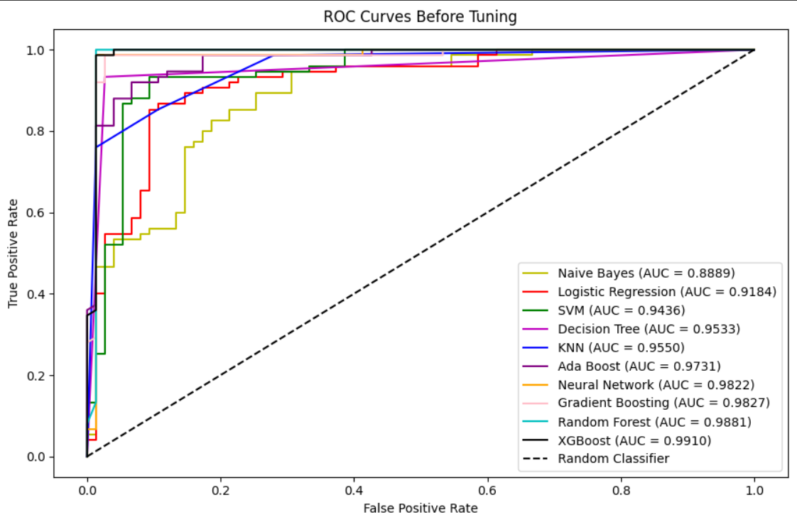

The ROC curves evaluated on the testing set show that **the XGBoost model outperforms** the others, with **AUC score of 0.9910**. Its ROC curve is closest to the top-left corner, indicating high sensitivity and a low false positive rate. This demonstrates XGBoost's strong ability to accurately distinguish between the two classes with minimal error.

We could also observe that several of the tree-based models are performed better compared to other models:

* **Random Forest (AUC: 0.9881)**
* **Gradient Boosting (AUC: 0.9827)**
* **AdaBoost (AUC: 0.9731)**

These models demonstrate strong performance, reinforcing the idea that **ensemble tree methods** are powerful classifiers for this dataset.

# ROC curves across different hyperparameter tuned models (after tuning)

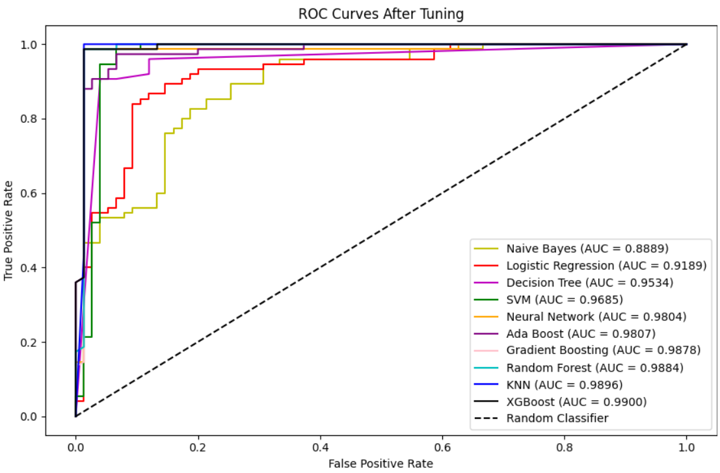

After hyperparameter tuning, most models showed improved ROC performance, with XGBoost remaining the top-performing classifier (AUC = 0.9900) due to its high true positive rate and low false positives. Tree-based ensemble models—Random Forest, Gradient Boosting, and AdaBoost also performed strongly, benefiting from optimized parameters like tree depth and learning rate.

The Neural Network maintained its robust performance (AUC = 0.9804), while KNN showed a significant boost (AUC = 0.9896) following tuning. SVM also improved notably (AUC = 0.9685), thanks to better kernel and regularization settings. In contrast, Logistic Regression and Naive Bayes showed little to no gain due to their inherent model limitations, and Decision Tree remained less competitive. Overall, ensemble models and XGBoost emerged as the most effective classifiers for complex tasks post-tuning.

**5.3 Model Selection**

In conclusion, after evaluating ROC curve and AUC scores**, we selected the XGBoost model with hyperparameter tuning** despite a very small AUC drop (about 0.0001) because the tuning helps improve generalization and model robustness. While the AUC decrease is minimal, the tuned model is less likely to be overfit and is more stable across different datasets. This makes it better suited for real-world use, where consistent performance on unseen data is more valuable than a slight edge on validation metrics.

# best_xgb_model is the XGBoost model after tuning with best parameters

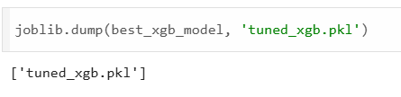

The XGBoost model after tuning is saved as ‘tuned_xgb.pkl’ so that we can use it in predict new datasets.

**6.0 Model Interaction**

**6.1 Data Preprocessing on new Datasets**

In this section, we will load the model we saved just now and use it to predict new datasets, namely ‘HeartNewPatients.csv’. Firstly, we apply the same step as data preprocessing we done in the initial stage. However, we will use back the same yeo-johnson transformer, standard scaler and label encoder that ‘fit_transform’ on training set to the new datasets to ensure consistency. What we have done on the training sets should applied on the datasets we want to predict to ensure the results we obtain are accurate.

# initial data

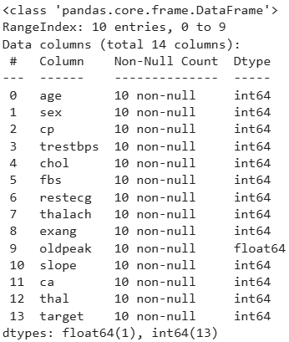

# No null values 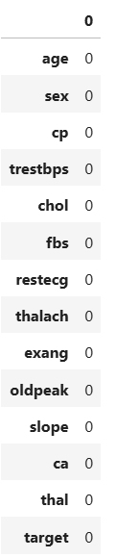in the new datasets

# Convert new data to categorical

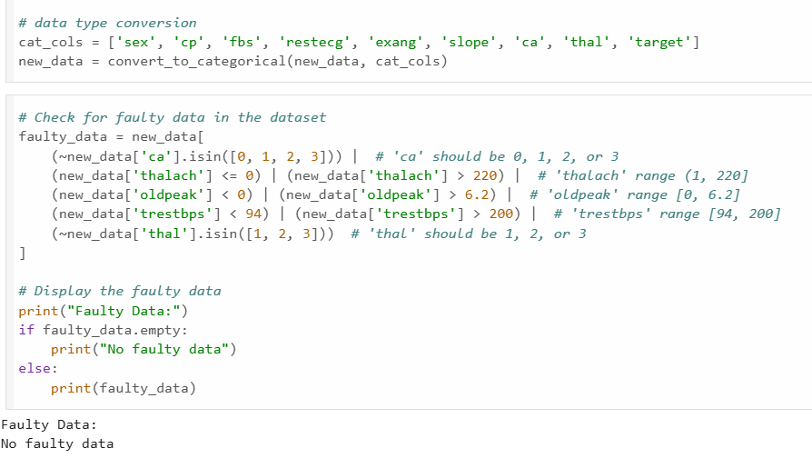

# No faulty data present in the new datasets



# Load the transformer, scaler and label encoder we saved previously

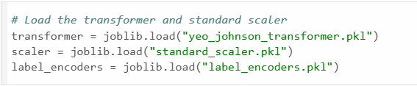

# After transformation

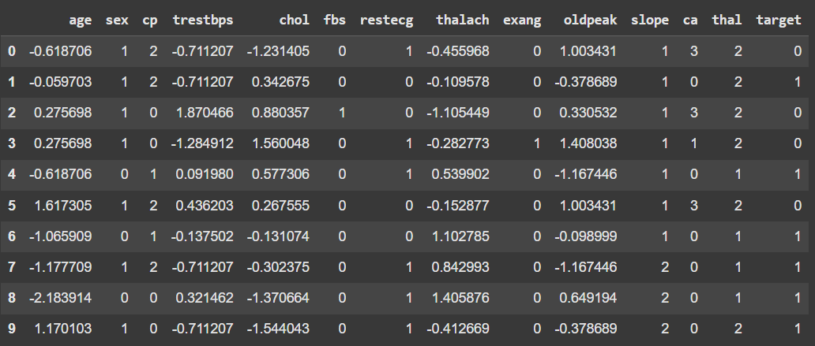

* The original thal variable included values 0, 1, 2, and 3, where 0 represented faulty data and was removed. After converting to categorical and applying label encoding, the valid categories (1, 2, 3) were reindexed to 0, 1, and 2.

**6.2 Data Prediction**

# Result of prediction

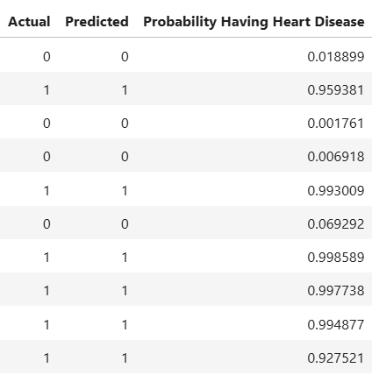

After performing the data preprocessing, we predict the result using the model we had trained. We could observe that the actual and predicted target variables are all the same. This indicates our model predict well on unseen data. However, we still need to put more data into our models to ensure it really generalizes well on real world scenario.

# Model integration into a simple system

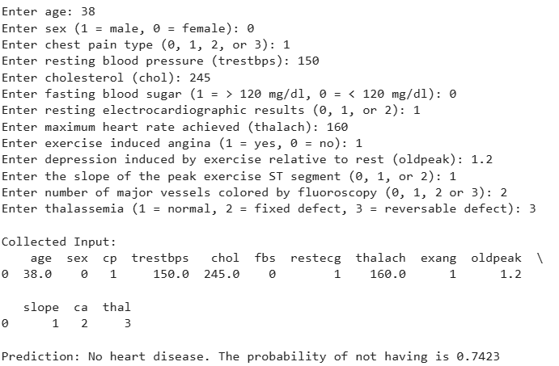

We also code a simple system that allows user to input their personal data and the model we trained will be used to predict whether the user has heart disease or not along with probability.

**6.0 Remarks and Reflection**

There are a few difficulties and issues that we noticed in the process of doing this assignment, The first noticeable issue is regarding the dataset. From our dataset, there are only about 1000 rows of data for us to work on. Although this may be beneficial as it reduces the running time of our model, the lack of data may also give us an inaccurate result. This is a serious issue as we are working with health-related data prediction, and we would need our result to be as accurate as possible. So larger datasets are strongly required to make our models are able generalize well on unseen data.

The second issue about our dataset is the anonymous label for the variable. An example of this can be seen in gender, where some online report categorized 0 as male while 1 as female while others have categorized 0 as female and 1 as male. In this assignment, we have followed the categorization in accordance with majority of the report which categorizes 0 as female and 1 as male. There were also issues such as extreme value or missing value in our dataset which we have solved in our data pre-processing steps.

The third issue that we face is the mixed-up steps in our data pre-processing stage. Initially, we performed our data pre-processing and data cleaning before data splitting step as this is what we have read from some of the sources online. However, we have switched to doing data splitting first then continuing with data pre-processing as this prevents the issue of data leakage after our splitting process.

For future enhancements, we planned to include more data and integrate additional datasets as many factors that might contribute to heart disease. By expanding our data sources, our model will be a more powerful tool for identifying heart disease cases. This approach brings innovative to the medical field.

From this project, we learned that data preprocessing is one of the most critical steps. If not performed all the steps properly, it may cause data leakage, which is a serious issue. Besides, we also investigated different models and observed majority of the real-life data is nonlinear, in other words we may use tree-based model, neural networks frequently compared to other simple models. Based on our final model, we claimed that chest pain type (cp), number of major vessels colored by fluoroscopy (ca) and Thalium stress test result (thal) are the main factors contributing to heart disease which was something interesting. Lastly, we would like to share a thought that guided us: ‘Don’t just predict the future, build a better one.’